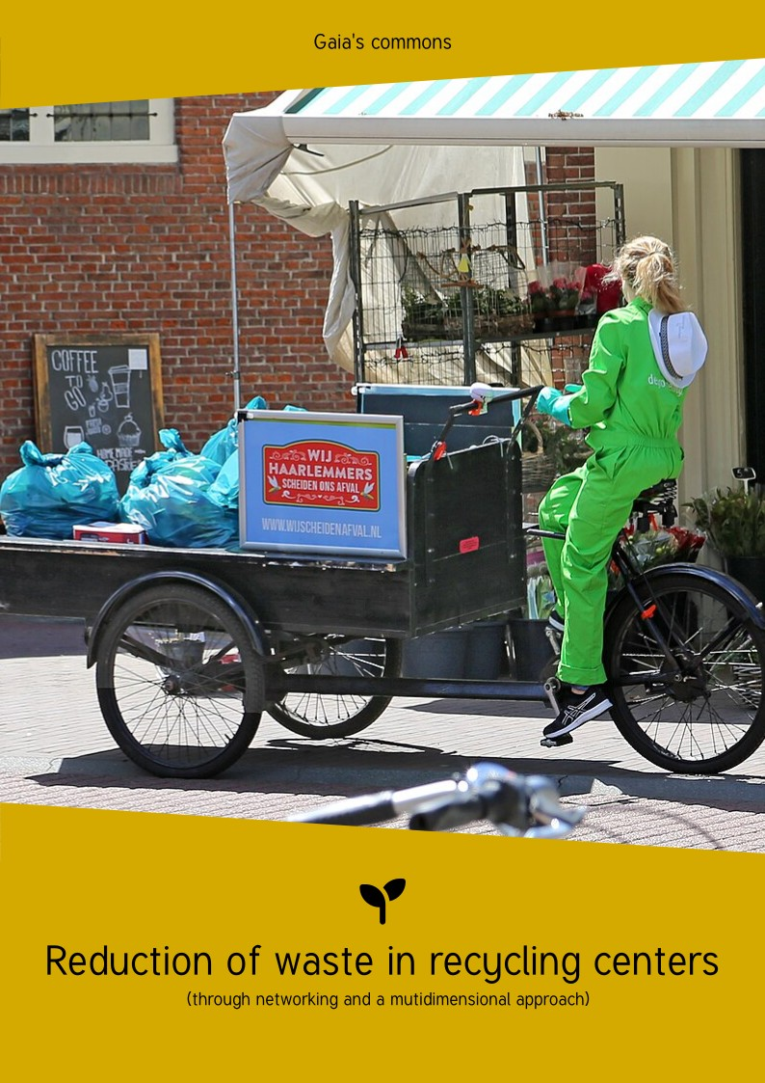

Table des matières 1
Foreward 2
Licences 3
Introduction 3
Information 4
Reduction of waste 4
Locations 8
As close as possible 8
Place of global upcycling 8
Neighbourhood composting 9
Inside the recycling centers 10
Information 10
Salvaging 10
Sorting skips 11
Actors 14
Conclusion 14

Foreward
It has been clearly and generally acknowledged now that the « best waste is the one that we do not generate! »
Recycling centers often symbolise the end of life of products we give away. It is true that recycling has been more and more of a habit, but let’s not forget that European laws acknowledge it is paramount to reuse and to upcycle as the environmental impact is not as high.
Some issues also have to be taken into account upstream from recycling centers, such as eco-designing, non-consumerist mentalities, returnable items, obsolescence, amalgamated, polluting or toxic products… But here, we will focus on the recycling centers which can be a genuine tipping point for waste to become resources.
This book was designed as collaborative work, so you can complete it or make it more coherent if you wish. This document is undoubtedly imperfect, incomplete and may contain mistakes. Please contact us at bonjour@graineahumus.org so you can help us improve it. Together, let’s go further! Enjoy your reading!
You say: « This thought is mine. » No, my brother,
It’s in you, nothing is ours.
Everyone has had it or will have it. Daring abductor, To the ordinary domain far from taking it away, Return it as a delivery: Sharing is so sweet!

Henri-Frédéric Amiel, Nothing is ours

Licences
The textual content, as well as the visual products generated by us, are under CC0 licence.
CC0 licence authorises anyone who wishes to freely reuse this work, to improve it, to modify it, whatever their purpose is and with no restriction of rights, except those which are required by law.
This document was created using Libre Office (Mozilla Public Licence) and Inkscape (GNU GPL).
The font Tuffy (Public domain) was used.
The icons come from Font Awesome under Creative Commons BY licence.
The cover picture was taken by W. Bulach under Creative Commons BY-SA licence.
The back cover picture was taken by Compost'Tout under Creative Commons BY licence.

Version 1 (August 2025) by Ben LARCHER, member of the association « De la graine à l’humus » (“From the seed to humus”).

Read the latest version on www.graineahumus.org.

Introduction
In this guide, you will find very concrete solutions to reduce waste through a multidimensional approach, but also a network of the various multiple contributors to this domain.
We explain concrete cases in France or abroad, methodological adaptations, some reflections that are less common…
The key elements of this guide are:
- Networking with the other contributors;
- Access to information about the least environmentally impacting waste management practices;
- Sharing paper and digital resources under free licences (software and database);
- Transparency on the local openings;
- Participatory and active democracy.
These five aspects help provide a necessary pool, because waste is « a negative ordinary”.
The ordinary refer to resources that have a use for everyone and which need to be taken care of collectively. These positive ordinaries can be material (water, air, forests…) or immaterial (shared knowledge, free or open-source softwares…).
The notion of « negative ordinary » is connected to the heritage of human culture with negative impacts (environmental, cultural or social). We also have an ethical duty to collectively manage them in the best possible way.

Using a positive ordinary (free or open-source licences) is thus a symbol of how an ordinary helps another negative (waste) become a resource, which entails a reduced impact on a positive ordinary resource (the material having helped build objects).

Information
First of all, recycling centers can provide information to the users, so that they avoid throwing away what they came to drop off.
People can be informed by means of a website, or on the premises at the entrance of the recycling center or yet again by skilled tip technicians.
There are various typologies of users who will have different needs. There are professional users and private individuals.

Reduction of waste

Guides of good practice
You can find guides on waste reduction through good composting practices, on food management, on making home-made cleaning products and other zero-waste practices.
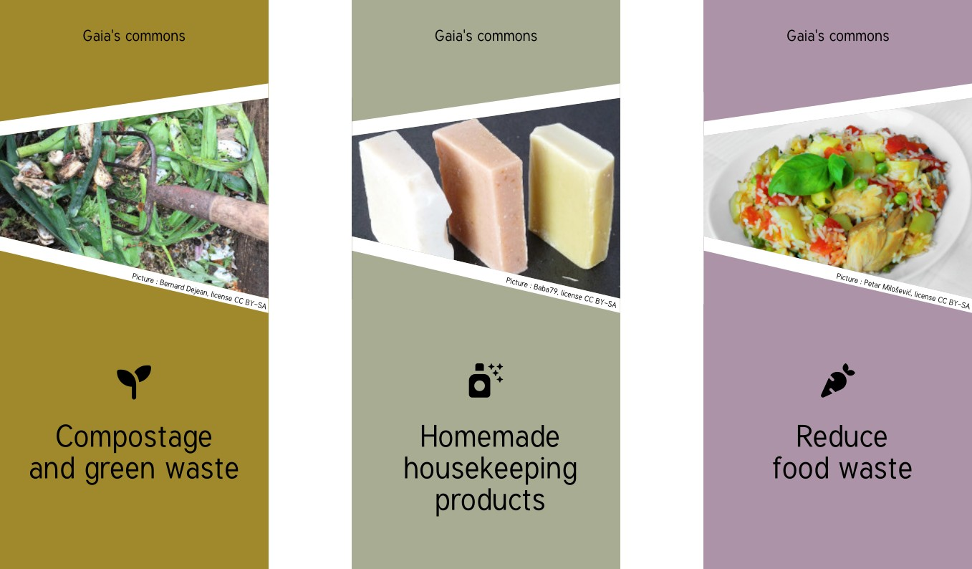Fictitious examples of guides.

At first glance, these guides can be used throughout France, in terms of content.
If they are under free licence, can be printed for free, can also be ordered and incite people to provide their feedback for continuous improvement, it’s even better!
A free licence enables sharing in various languages and ensures that people do not reappropriate “negative ordinary” issue-solving tools that are waste.
We can also include the apps and websites useful for the donation of objects.
For the companies, there are also some “waste exchange fairs” websites and apps or donations of pallets, for example.
Being a reference in guide designing, we think about examples such as the brochures we can find in info-energy areas and which can be found all around France.

Obviously, these guides must be approved by experts, such as the ‘citizen composting network », for example. Indeed, if more and more homes have individual compost bins, some people quit compost due to compost bin ill-management reasons, for lack of carbon material, due to bad locations or inadequate compost bins.

Guide of the local good addresses
It is extremely frequent to have waste reduction actors (associations, authorities or companies) nearby.
Again, we can prepare a local contributor guide to be given to users.
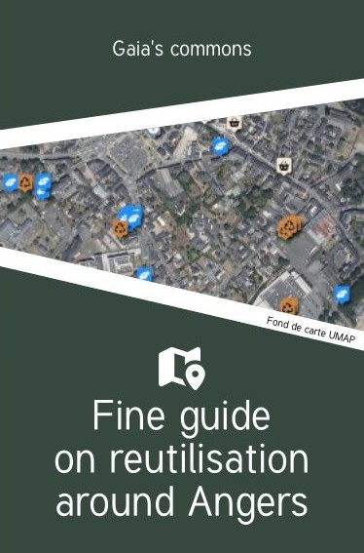Fictitious example of a guide of good addresses.
This guide could not be used throughout the French territory in terms of content, but still, it is possible to prepare a reproducible template, always available under free licence.
Indeed, salvaging (corks, material, metal products, cardboard boxes in large quantities, books, textiles, various plastic products…) is quite frequent. It should be noted that for interenterprise business (B to B), buying back plastic material is a common practice that is far more profitable when plastic material is divided into categories (PVC, PET, HDPE, PS…). Plastic purchasing professionals can guide the suppliers in this practice.
There are also repair workshops, fab labs, computering repackagers, the repairers, the material libraries, resource providers, recycling shops, sewing workshops, shoe repair shops, specialised associations, donation places…
In short, a free-licence guide which incites people to contribute to its improvement, is saving time and money significantly, especially for the smallest towns that do not have the same financial means as the bigger towns.

Map of the good local addresses
A place also needs to be mapped!
This can easily be twinned with the guide of the good local addresses, by opening the map to the contributors who will feed the paper guide in the future.
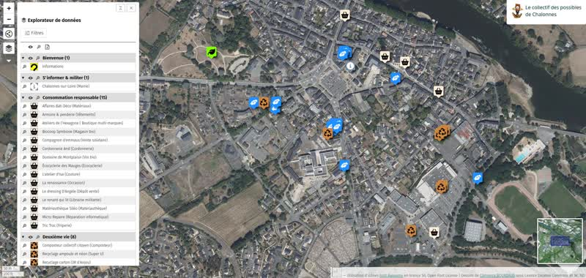Fictitious example of a map drawn with UMAP.
There are national mappings of good local addresses. They are not always up to date, not always free of use, not always shared, not always optimised…

Open data
Open data are digital data of which the access and the use are free of use for users. The open data help separate data from their use. One single database can thus be used for everyone by only displaying the required data (by location, by category…).

The database is thus easier to update and does not require soliciting the contributors on multiple occasions. We can date back a change (shutdown of the structure, relocation or other) to keep the data updated. We can send an annual email to the structures to ask if all the data is updated.

Open source
Data is one thing, but the software solutions are another one. There are solutions that are free, documented, well-performing solutions which can be exploited to make a map.

For the most straightforward uses
Umap (https://umap.openstreetmap) can quite easily use distant data from a database in open.

A computer engineer can also help you by « plugging » to global data that is too large, filter them by creating a file adapted to your needs and which is updated automatically. This file is then used to feed the map. The code used for this operation can be shared under free licence.

For the most advanced uses
Leaflet (https://leafletjs.com/) is the international reference.

A map to govern them all
We can also create a general map from Leaflet or Umap which use permalinks, ie. they generate links that only contained the desired area, as well as the display of the desired categories only.

It helps integrate the map in iframe on a website or generate a simple link that only contains the desired information.

Such a map helps the structures that ca not afford to easily provide a wide-ranged solution for a multitude of contributors!

From open data to local use
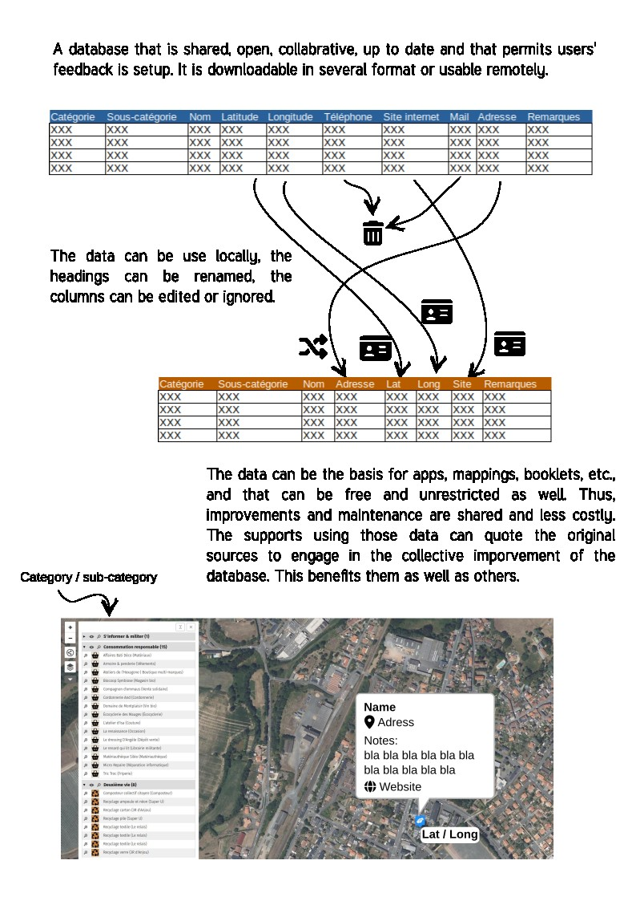

Locations

As close as possible
The location of the recycling centers and the eco collection points helps to design the management as close to the user as possible.
So, we are in an on-the-spot, district management. We make local reuse and upcycling our first priority, even if it means having more spots where not everything can be dropped off. We can choose not to accept any large cumbersome drop-offs, any gravels, etc. but rather an on-the-spot sorting for “waste more of a household nature”. That is what is generally proposed by eco collection points.

Place of global upcycling
When we give away objects in bulk (moving out, going to a retirement home, death…), we can wish for maximum upcycling. It can be very tricky…
Dropping reusable objects in one single place make it very easy. A place such as a storage building can be used as dropping place for a later donation to associations or expert companies when the quantities are quite large. This location can also help resell to private individuals or to companies what cannot be salvaged by local actors.
A community test in Rennes was using coloured dots to mark objects for the objections with a function (small electrical and electronical equipment, mechanical objects…).

Green dot: everything is working well

Orange dot: a small problem has been explained on a form,

Red dot: does not work, some parts might be of interest.

Neighbourhood composting
Neighbourhood management places, such as neighbourhood composting of on-the-spot collective composting, help manage a local resource more closely, without the transport and infrastructure impacts. Associations, often close to the « citizen composting network », in France can help implement a process such as this one.

Inside the recycling centers

Information
As we have previously seen it, information is a crucial “key”. Not only for what is happening inside the recycling center, but also for the part played by external local actors.

Salvaging
Salvaging in recycling centers is more often than not for the benefit of an association (recovery center, bike workshops…). Indeed, as far as private individuals are concerned, it is acknowledged that the person must not be endangered while recovering an object. However, we will see that there are some exceptions to this and that some towns tolerate it, and even encourage it.

Place of recovery
A covered place of recovery, just upstream the recycling center, allows for recovery. Anything that is still functioning or with minor problems or which can be used again, is dropped off. The users can take what they want, free of charge or at little cost.

Travelling people
Travelling people are historically linked with salvaging in recycling centers.
Indeed, in Europe, the first recycling centers were created in the 1970s. Prior to that, wild or open-sky drop-offs were carried at the town limits, where the travelling people were also rejected, though it had been existing since the Middle Ages.
Their nomadic lifestyle worked well with some trades, such as door-to-door salespeople, seasonal workers but also waste-related trades such as scrap metal merchants or ragmen. When recycling centers began to upcycle waste that were previously upcycled by travelling people, a simple ban on salvaging was adopted.
However, some towns like Nantes supports material recovery by travelling people or yet again Rezé associates seven travelling people, united in an economical interest grouping.
Technically, in a formal system, travelling people who come to some recycling centers, can ask to see what is being thrown away to salvage it, which can be of interest.
Flag of the Gitanos.

Hook fishing
Finally, some recycling centers simply accept the salvaging of anything that can be found in the skips, under certain conditions.
People can neither step down into the skip nor bend over it to salvage something, nor apply any strength if something has a grip on the much-coveted object. Ropes or hook-fitted sticks can be used to salvage what can’t be reached.

Sorting skips

Incitement to drop off elsewhere if the object is functional
First of all, we can target information according to the related skip for a donation to an external organisation, by stating the terms. For example:
- Near Electrical and Electronical Equipment Waste (EEEW): donation to a laptop computing reconditioner, starting from the i3 even if it is no longer functional, recovery of computers with a broken screen for computers used by blind people, recovery of small EEEW by such organisation, repair workshops at such day such place…
- Near materials: recovery of concrete blocks, of paint, etc. for professional training certified people in construction, location of an on-the-spot material library…
- Near organic waste: proper organisations which salvage organic waste, contact details of a master composter to set up another on-the-spot solution…
- Near pallets: proper websites and apps dedicated to pallet salvaging.
- Near cardboard: proper upcycling artist specialised in making cardboard furniture, cardboard-recycling organisation.
- Near paper: proper integration building yard which salvages it and transforms it into packaging wedging.
- Near miscellaneous materials: proper websites and apps dedicated to salvaging miscellaneous materials.
Then again, we see the relevance of creating display templates under free licence, from software that are free, reputed and access-free, while providing educational software to reappropriate tools and modify contents.

Salvaging near skips
We can allow a drop-off near the reusable material skips, or even provide a shelter and a drop-off on pallet for anything that is humidity-sensitive,
This drop-off is emptied every XX day in shifts.
Anybody who throws away materials can work in a field related to material or carry out personal work. They are more likely to be interested by other things of this category for their job.

Specific case

Materials
All non-amalgamated materials can potentially be reused. The thing is, once they are thrown away in piles, reuse is no longer possible.
Paint, bricks, concrete blocks, raw wood, weldable metal, corner mouldings, cornier pieces, slates, wheels, window/door frames, handles, plasterboard, fitted carpet, rocks, stones, sand, soil, etc. that are not amalgamated must be properly separated. Even small quantities can be of interest.
As for parts, objects have to be disassembled to access them.
Objects such as bikes can also be put aside as they are.
We usually favour as-it-is reuse, but spare parts can be used if this option is not possible.

Pallets
Pallets clearly represent resources. There are several options. They can be disassembled with a pallet stripper. Nails can to go through a grinder on their sharp end, before being removed with a hammer (ex, sharp end) and a pair of pincers (head-side of the nail).
Pallets can also be stacked vertically, with rods to prevent them from falling.
It can be interesting to inform people of the pallet class with a picture showing EPAL 3 pallet marking (outdoor-resistant, 7-to-10-year life duration in intensive use of heavy loads).
For pallets that are not of class 3, it is preferable to provide a shelter and a class 3 pallet stacking, to prevent any rotting. They can easily be reused indoors.
Some people and companies buy back or repair pallets.

Plants
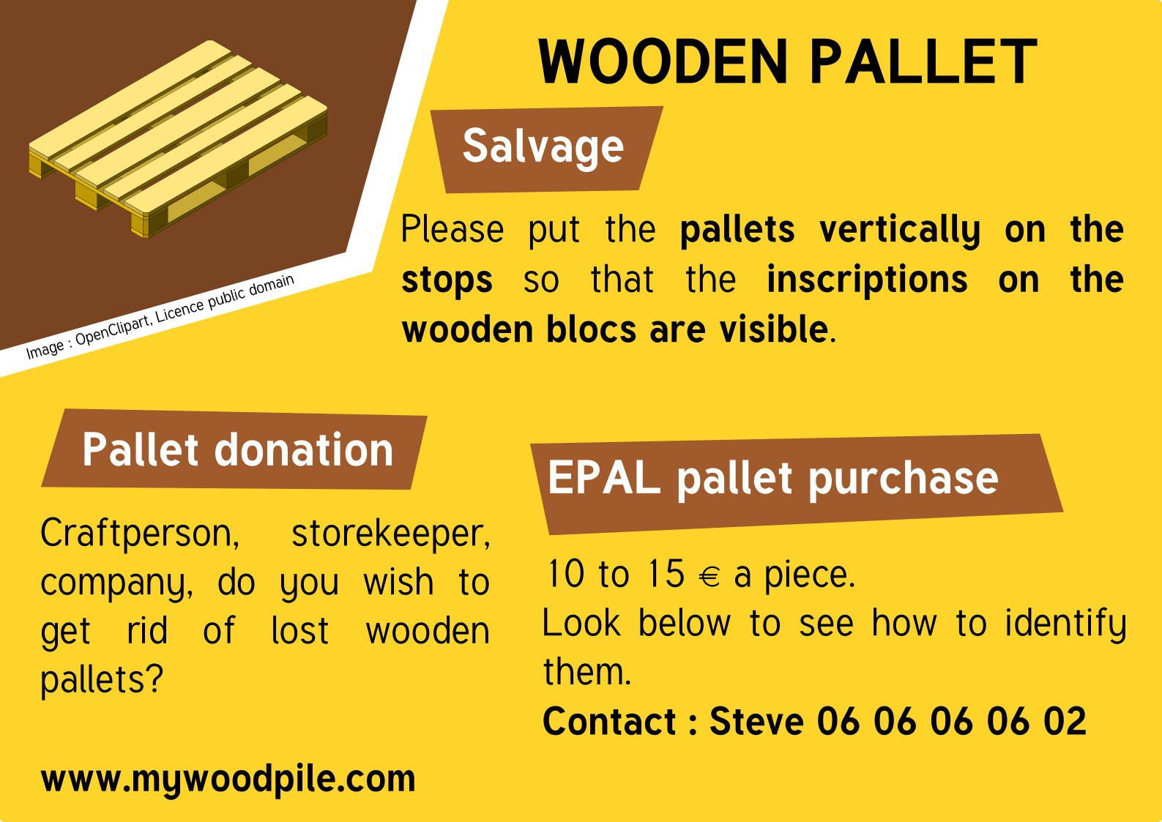Fictitious example of an indication for pallets
Plants represent real resources. They can be ground and ground material can be offered on a regular basis.
Rennes refuses lawn cuttings and proposes other approaches.
Plant recycling centers are also set up to simply refuse plant resources in standard recycling centers.

Plastic
Sorting plastic into categories is far more profitable than selling it… When a company has a certain amount of plastic, contacts details can be provided so that plastic can be bought back.

Actors
The identification of actors by managers can be made easier by online research, existing databases, the directory or also listings of the organisations present on the territory.
This proactive approach is not the only role of waste managers. Let’s not forget these are ordinary. So, the implementation process of a participatory and active democracy can be supported by local authorities or relevant local volunteer referees.
It is important to go on the grounds of the recycling centers to become aware of the realities and consider how to reuse. It is helpful to include recycling agents and all involved parties in this consideration.
When no solution can be found onsite, it is helpful to talk to the waste union networks to find out what outcomes have been found elsewhere.
When a one-of-a-kind solution is found, it is helpful to talk to waste union networks and the general public to raise awareness on this new outcome.

Conclusion
A recycling center is a resourceful place in disguise.
Yes, not everything can be reused and this should not trigger any further upstream reflexions to limit waste in a more drastic way.
By regarding this place as an ordinary to be managed together, through sharing transparency, recycling centers become a place of information and potential to the territory and its actors.
To choose a participatory and active democracy is to choose a collective management over a collective problem, which helps elaborate multiple local solutions.
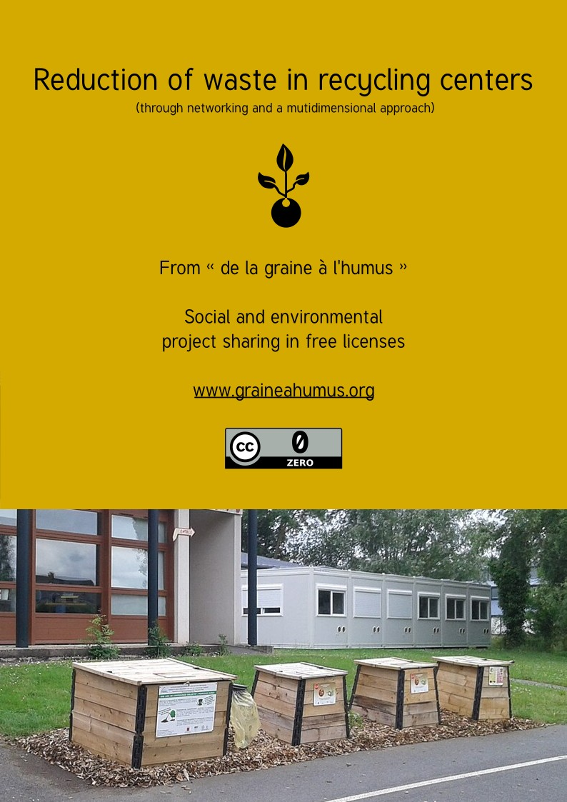

The Board insists on the necessity to encourage waste upcycling as a means to reduce the quantity of waste to be disposed of and save natural resources, for instance through reuse, recycling, compost and energy recovery of the waste, and it acknowledges that the choice of the option to take in each specific case should be made by taking into account the environmental and economic impacts, while we wait for actual scientific and technical progress and for the development of life cycle analyses. Material reuse and upcycling should generally be considered the first choice when they represent the best options in terms of environment. DIRECTIVE 2002/96/CE OF THE EUROPEAN PARLIAMENT AND THE BOARD dated 27 January 2003 related to the electrical and electronical equipment waste (EEEW). Article 4: In its resolution dated 24 February 1997 on a community strategy for waste management (JO C 76 dated 11.3.1997, p. 1.)
NDLR: My personal record comes to over a dozen drop-offs in different organisations to recover all categories of objects in the midst of moving abroad.
Even recovery centers do not accept everything.

