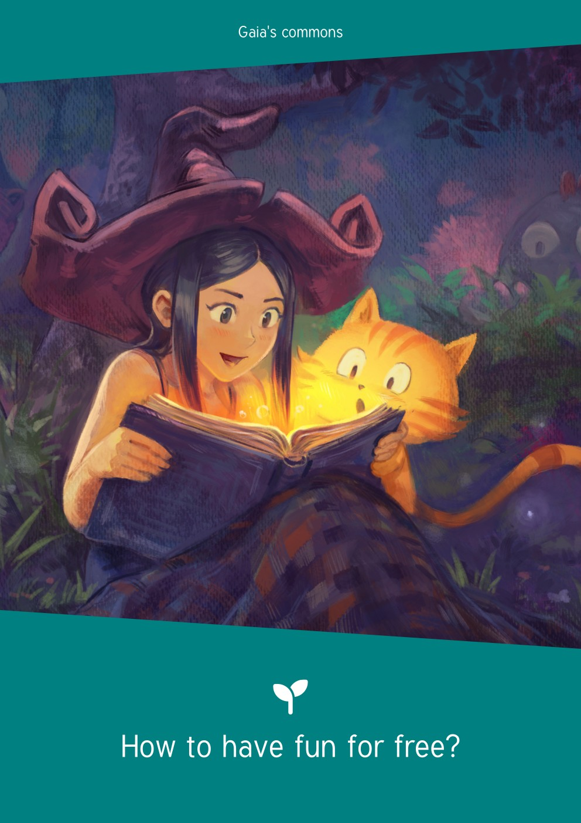
Les communs de Gaia
Index
I. Preface 1
II. Licenses 2
III. Introduction 3
IV. Who am I? 4
V. Categories 5
VI. The hangman 6
VII. The wall 7
VIII. The carpet game 7
IX. The pellet game 8
X. We will rock you 9
XI. License plate 9
XII. Count to 20 10
XIII. The word 10
XIV. The disease game 11
XV. Exquisite corpse 12
XVI. Rockin’ palet 13
XVII. Game of the dictionary 14
XVIII. The corner game 15
XIX. Mega tic-tac-toe 16

Preface
We wish for this document to become a collaborative source of games shared freely and unrestricted.
You say: “That thought is mine.” No my brother,
It is in you, nothing is ours.
Everyone has had it or will have it. Reckless kidnapper, In the common domain, far from subtracting it, Make it like a deposit: Sharing is so sweet!

Henri-Frédéric Amiel, Rien n’est à nous (Jour à jour, 1880)

This document is definitely imperfect, incomplete, and may contain some mistakes. You can contact us at bonjour@graineahumus.org to take part in its improvement.

Find the latest version on www.graineahumus.org.

Licenses
The written contents of this document are under CC0 license.
The CC0 license allows anyone to freely reuse, improve, and modify this work, regardless of the goal and without any rights reserved to the fullest extent allowed by law.
This document was made with LibreOffice (Mozilla Public License) and Inkscape (GNU GPL).
We use the Tuffy font (public domain).
The cover and back cover illustrations were made by David REVOY (Creative Commons BY-SA license).

Version 1.1 (August, 2025) by Ben LARCHER, member of the association “De la graine à l’humus”.

Introduction
We want to showcase free games, easy to set up with what we have at hand.
We will not talk about the reproduction of games like Battleships, oware, merels or the many more that can be adapted.
With five dices, a deck of french tarot cards and a deck of 54 cards, it is certainly possible to do a lot of games with not a lot at hands. Let’s go even further!
We will see here how to set up a game in less than five minutes with what we have at hand. It is good for your walled and for the planet!

Who am I?
The goal of “Who am I?” is to find the identity of the character stuck on your forehead by asking questions that can only be answered by “yes” or “no”. The winner is the one that finds their character first.

Set up
- The players each write the name of a famous person or a fictional character on a piece of paper.
- Everyone gives their paper to their right neighbor (or left, the important is, everyone has the same direction).
- When a player receives a paper, they show it to the other players without looking at it.
- During their turn, the player tries to guess who they are by asking questions that can only be answered by “yes” or “no”. If the answer is “yes”, the player asking questions can ask one more. If the answer is “no” it is the turn of the next player.
- The game stops when a player guesses their mystery character during their turn.

Variation 1
The players can write names of objects, animals…

Variation 2
Only one player thinks about a famous person, a fictional character, an object, an animal.
In turn, the other players ask a question that can only be answered by “yes” or “no”. If the answer is “yes”, the player asking questions can ask one more. If the answer is “no” it is the turn of the next player.
The game stops when a player guesses the answer during their turn.

Categories
The players need to find, in a limited time, a series of words starting by the same letter and belonging to specified categories.
To play this game, each player needs a pencil and a piece of paper.

Set up
- The players define ten categories (name, famous person, city, country, animal, fruit, object, game, sport, book, movie, video games…) that they write on a paper as names of columns (one for each category). They also add a column for the letter chosen and for the points.
- In turn, the players pick a random letter by saying the alphabet in their head. Another player says “stop” to choose the letter.
- Every player must write a word starting by the chosen letter for each category.
- The round stops once a player found a word for every category.
- Every unique word scores one point.
- The game stops after a definite set of rounds.
- The player with the highest score wins.

Variations
There are lots of variations, the players can:
- in turn, decide of the letter;
- stop the round if everyone agrees or after a time limit;
- gain two points for each unique word and one point for words you have in common;
- only gain points with words that you have in common;
- do every letter of the alphabet…

The hangman
The goal is to guess a word with limited tries.

Set up
- A player writes a number of dashes equal to the number of letters of the word they are thinking about.
- In turn, the other players ask if the word contains a specific letter. If the letter is in the word, then it is added on the dash where it is located. If it is not, a line is added to the hangman drawing (11 lines total, more or less depending on the variations).
- The game stops once the word is guessed (the guessing players win) or if the drawing is finished (the player who chooses the word wins).
- Example:

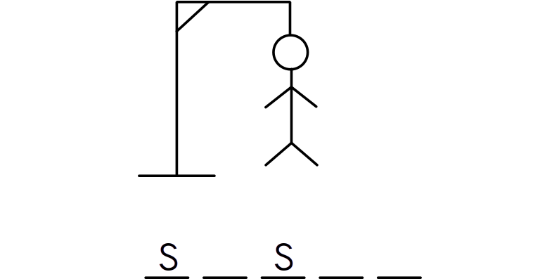
Variations
It is possible to write the asked letter at every occurrence in the word, or only in a single place. However the players need to call the rule!

The wall
It is a game of skill to play outside.

Set up
- Draw a three foot (one meter) long line, two feet (60 centimeter) away from a wall, parallel to it. Draw a throwing line of the same length at around seven foot (two meters) from the first line, so around ten foot from the wall.
- Every player has three rocks that are distinguishable from the rocks of the other players, like with markings or different colors.
- At the throwing line, the first player throw one of their rocks. It must land between the line and the wall but it cannot touch the wall. The rock is removed if that happens.
- In turn the players throw one rock.
- At the end of a round, the player with the rock the closest to the wall scores one point, and one more point if the second rock the closest is theirs, and the same for the third rock.
- The game stops when a player reaches ten points.

The carpet game
It is a cooperation game.

Set up
- The players stand on a big carpet, or tarpaulin (enough players to fill half the space if they squeeze a bit).
- The goal is to stay on the carpet while it turns upside down.
A narrative can be added to justify this situation. For example, it can be a flying carpet, but it is upside down. If the players do not stay on the carpet, it will take advantage of it and fly without the players to be free again.

The pellet game
It is a game of rapidity, where the players need to guess the most words possible.

Set up
- The players divide in two teams. Every player has eight pieces of paper.
- Each player writes one unique word on each of their piece of paper, and then they roll each piece into paper pellets. All the pellets are gathered in the middle of a table.
- In turn, the players have 1 minute and 30 seconds to make their team guess the most words possible.
- First round: one player describes the word they picked without using the written word nor a word of the same family.
- Once the time is up, the teams count the scores (one point for each found word).
- Second round: one player describes the word they picked with only one word, still without using the written word nor a word of the same family.
- Once the time is up, the teams count the scores (one point for each found word).
- Third round: the player mimes the word they picked.
- Once the time is up, the teams count the scores (one point for each found word).
A player can pass a word if their team can not manage to guess it.

We will rock you
A game of rhythm and memory. Three players minimum.

Set up
- Every player chooses a unique sign to do with their hands.
- In turn, every player shows their sign to the others.
- The game starts following the rhythm of “We will rock you”. The players hit two times their thighs, then clap their hands once and repeat the rhythm.
- The player starting the game will do their sign instead of clapping their hands, and on the following rhythm, they will do the sign of another player.
- The chosen player will then have to do their sign and the sign of another player, still in the rhythm.
- If a player gets a sign wrong, they are eliminated until only one remains.
A player can, during their turn, accelerate the rhythm, but never decelerate.

License plate
Look for the state [or region of your country] on the license plate. Ideal to keep children busy during car rides.

Set up
- Look for the state [or region of your country] on the license plate.
- Keep a list updated about the states [or regions] you found and their location.

Variations
- It is possible to add the plates of other countries.
- The players can try to find or discover the region or the country found.

Count to 20
A cooperative game of memory. Three players minimum.

Set up
- The players sit in circle.
- A player starts by saying “one”, then it is the turn of the player on their right to continue saying the number in order. The starting player can also start by saying “one, two”, then it is the player at their left side to continue.
- The next player either says the following number, and it is the turn of the player on their right, or the two following numbers, and it is the turn of the player on their left.
- Keep going until one of the players speaks out of turn or says something wrong. The game then starts over beginning at zero.
- Keep counting to 20.
- Once you reach 20, switch one of the numbers by a word, and start over at one.
- Keep going until every number has been switched with a word and reach “20”.

The word
A game of linguistic knowledge.

Set up
- A player calls a letter of the alphabet.
- The following player adds another letter and thinks of a coherent word.
- The following players keep going the same way or try to bluff by asking what word the last player was thinking.
You can use an elimination system or count the scores.
Having a dictionary at hand may be useful.

The disease game
In this game, one player must guess the disease of the other players.

Set up
- One player, the “doctor”, is put aside and must guess the disease of the other players.
- The other players are in circle and they are interrogated by the “doctor”. The doctor must ask a different question each time.
- Examples:
- The first person will not answer, they are completely mute.
- The second person, for whom the question must be different, will answer to the question asked to the first person. Each person will answer to the previous question.
- The “doctor” must guess this state of delay.
The players can have other diseases, like being forbidden to say “yes” or “no”, forbidden to use the letter “o”…

Exquisite corpse
A game with lots of variations…

Set up
- Take a strip of paper and fold it in five, seven or nine even rectangles.
- The first player writes a word.
- The second player draws the word.
- For the third, the first rectangle is folded so that they can not see the first word. They write the word that the drawing is making them think of.
- Fold one more rectangle in the chronological order so that the next player can not see it. In turn, the players draw or write.
- At the end, for each word identical to the first word, the player who wrote the first word scores one point, and each player who wrote the same word as the first scores one point.
- The players rotate up one position at the end of the turn and keep tab of the scores.
One single player can not interact twice with the same strip of paper. The length of the strip must be adapted to the number of players.

Variations
- You can play in teams to avoid sabotage from other players.
- You can play only with words, without using the previous one. The players try to make the next player guess the previous word.
- You can try to write a story by writing each a sentence. You can add in between every sentence the words “but” and “so” alternately.

Rockin’ palet
Game of skill to play outside.

Set up
- Draw a circle two foot wide (60 centimeters), seven foot (two meters) away from a starting line.
- Every player has three rocks that are distinguishable from the rocks of the other players, they are called palet. They have different markings or colors.
- At the starting line, the first player throw another rock, called the “tiny”, smaller than the other rocks. It must land in the circle. They have three tries, after three fails the next player throws the “tiny”.
- Once the “tiny” is in, in turn, the players throw one palet. If a player gets closer to the “tiny”, it is the next player who plays, if not, they keep playing. If no other palet is in the circle, and a player did not place one of theirs inside, it is also to the next player to play.
- At the end of a round, the player with the palet the closest to the “tiny” scores one point, and one more point if the second palet the closest is theirs, and the same for the third palet.
- The game stops when a player reaches ten points.

Game of the dictionary
It is a guessing game based on a dictionary.

Set up
- A player chooses a difficult word in the dictionary and calls it to the others.
- Each then writes a definition of it on an individual paper. The true definition written by the player who chose the word is among the other definitions.
- The papers are mixed and read by the player who chose the word.
- The others vote for the definition they think is the true one.
- The player whose definition gets voted for the most scores as many points, or one depending on the variations.
- Switch for another player to choose a word each round.
Before beginning, decide of a score to reach to win.

Variation
Someone chooses a word in the dictionary and the other players need to guess the definition by asking questions that can only be answered by “yes” or “no”.

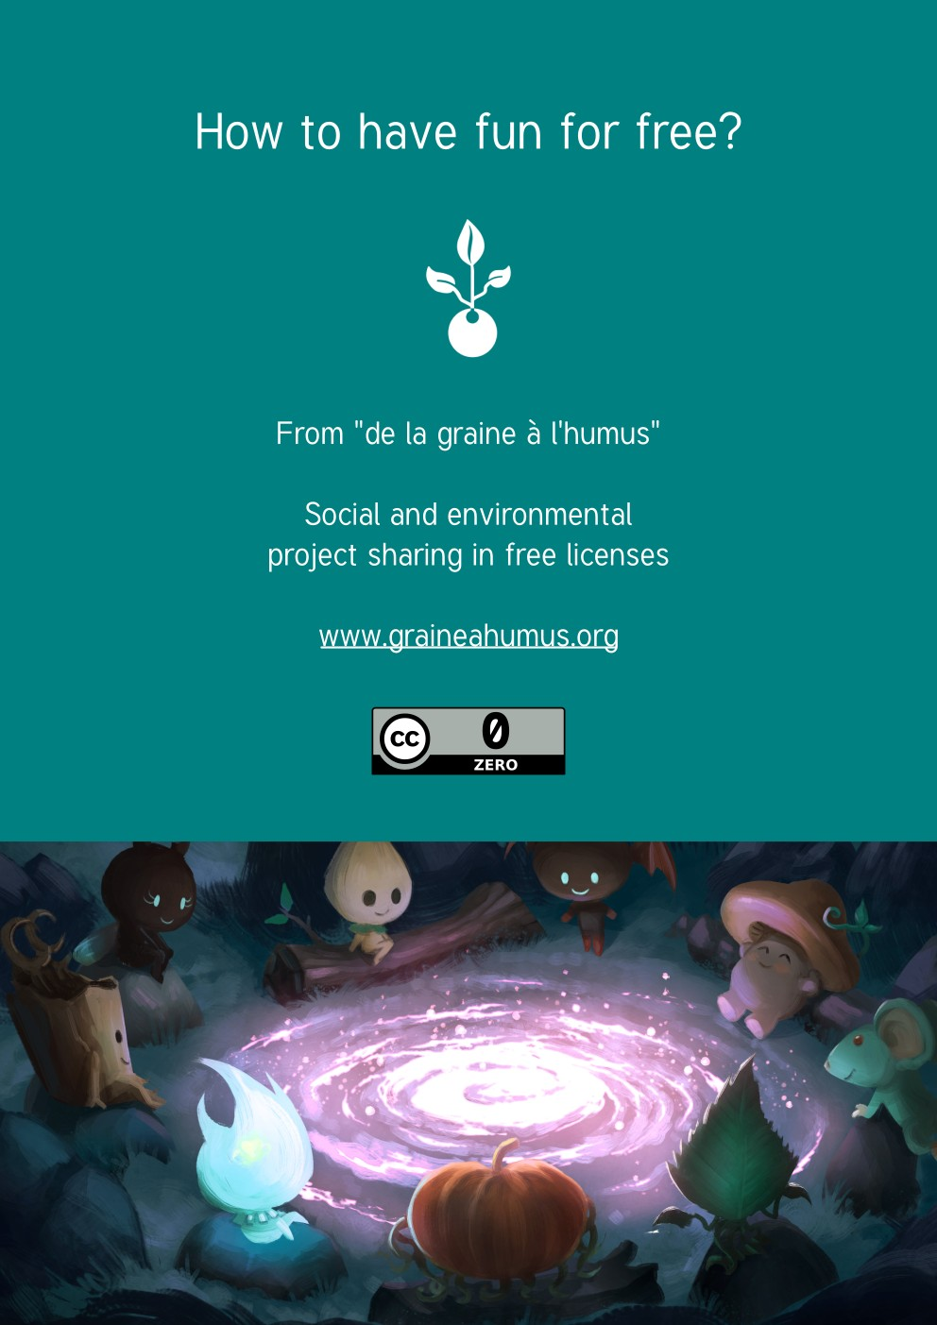
The corner game
Game of strategy and moving to play outdoor.

Set up
- Create on the ground as many corners as there are players minus one. It can be done with chalk, clothing, rocks, sticks…
- Every player goes to their corner and one player goes to the center.
- At the signal, every player needs to change corner and the player in the middle tries do go to a corner.
You can decide of a score to have to win, for example, a player scores a point each time they find a corner.
You can eliminate corners, or set a limited time to find a corner.
Depending on the age and the number of players, it can be done in a more or less big area.

Mega tic-tac-toe
Simple tic-tac-toe? No! Mega tic-tac-toe! This game needs two players.

Set up
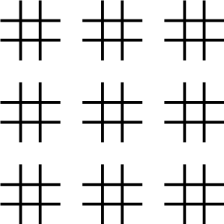
On a sheet of paper, draw nine grids of tic-tac-toe, on three rows and three columns as below.
- Like in tic-tac-toe, the players alternatively mark the spaces with Os or Xs. The first player marks a space.
- The second must play according to the location of the previous mark. For example, if the previous mark was placed in the top left corner of a grid, the next player must play in the top left grid.
- When a grid is won, using the same rules as tic-tac-toe, place the mark of the winner over this grid.
- Each grid acts as a space of tic-tac-toe, the goal is to align three marks over the grids.

