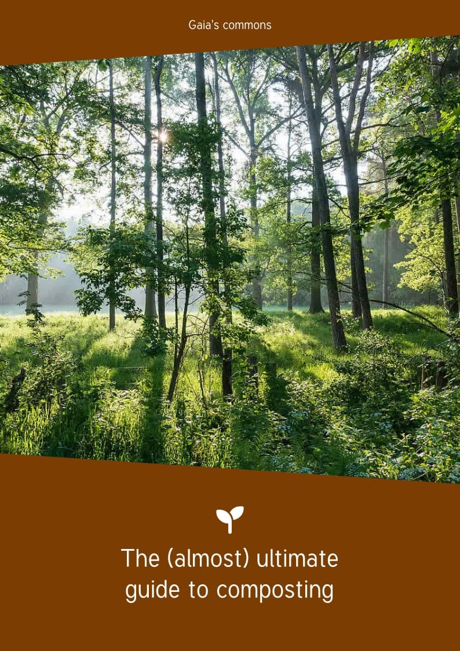

Table of contents
I. Preface 1
II. Licenses 2
III. Introduction 3
IV. Compost 5
IV.1. Etymology 5
IV.2. Definitions 5
IV.3. Different Types of Compost Bins 11
V. Compost chemistry 13
V.1. Respiration 13
V.2. Explanations 13
V.3. Fundamental elements 15
V.4. Carbon 16
V.5. Nitrogen 16
VI. Compost’s biology 20
VI.1. Aeration 20
VI.2. Humidity 20
VI.3. Living things 20
VII. Compost and humus 35
VII.1. Clay-humus complex 35
VIII. Types of soils 39
VIII.1. Components 39
VIII.2. Bioindicators 43
IX. Daily 51
IX.1. Principal 51
IX.2. Location 53
IX.3. Sizing 54
IX.4. Preparation of the terrain 56
IX.5. Materials 57
IX.6. Compost durations 60
IX.7. Maintenance 61
IX.8. Tools 63
X. Communication 66
XI. How to use a compost 68
XI.1. Types of use 68
XII. Resources 71
XII.1. Self-promotion 71
XII.2. Books 71
XII.3. Sources 71

Preface
Behind this pompous and somewhat sarcastic name, “The (almost) ultimate guide to composting” hides a utopia. What if, faced with environmental emergency, we were to freely share our knowledge of composting and bio-waste?
Could we, this way, take part in limiting soil pollution, and even allow it to renew? Could we take part in the development of local ecosystems? Could we reduce movements of agricultural inputs between countries and become more resilient? Could we considerably reduce our waste and consider it as a resource? Could we have a distant impact, although very direct, on the health of populations and ecosystems located near agricultural inputs extraction sites?
This work is based on free-culture principles, a social movement promoting the freedom to distribute and modify creative works. Behind this movement is an egalitarian thought of open access to information, a will to share without restrictions, using the free licenses allowing it. Moreover, collaborative work allows for multiple participations so as to improve works.
You say: “This thought is mine.” No brother,
It’s in you, nothing is ours.
Everyone had it or will have it. Daring abductor, To the common domain far from taking it away, Return it back like a delivery: Sharing is so sweet!

Henri-Frédéric Amiel, Rien n’est à nous (Nothing is ours) (Jour à jour, 1880)

This work is open to collaboration, for completion and coherence.
This document is definitely imperfect, incomplete, and may present some mistakes. You can contact us at
https://www.graineahumus.org/spip.php?page=contact to take part in improving this booklet.
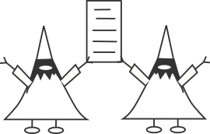

Licenses
The written contents of this document are in CC0 license.
The CC0 license allows anyone to freely reuse, improve, and modify this work, regardless of the goal and without any rights reserved to the fullest extent allowed by law.

This document was made with LibreOffice (Mozilla Public License) and Inkscape (GNU GPL).
We use the font Tuffy (public domain).
The icons are from Font Awesome (Creative Commons BY license).
“Les gnomes de livres” (“book gnomes”) are in WTFPL license (“Do What The Fuck You Want to Public License”).
Other licenses are mentioned as they are used. Unless otherwise specified, they are from Wikimedia Commons.
The cover and back cover picture was taken by Dietmar Rabich (Creative Commons BY-SA license).

Version 1.1 (March, 2025) by Ben LARCHER, member of the association “De la graine à l’humus”. Environmental engineer and free-culture activist. Knowledge in waste management, soils, compost, process analysis, garden habitats.
Thank you to Lydie FAVREAU, chemist, for proofreading.
Thank you to Compostri, for proofreading the content and bringing your expertise on various points (https://www.compostri.fr/). Thank you to Adèle, for proofreading. Thank you to Rose and Agathe, for information on sections’ development. Thank you to Philippe, for proofreading and uploading. Thank you to Efflam HIRGAIR (First year Master’s in Translation and Interpretation), for proofreading.
Translation and proofreading by Efflam HIRGAIR, Romane PIVETEAU, Clélia DIGUERRE, Jeanne MORALES, Gwenaëlle ROLLINAT, Lisa CAMELIN,
Maëla BODENNEC, Mathieu VANWALLEGHEM, students from the Translation Master’s Degree at Rennes 2 University for a volunteer project.
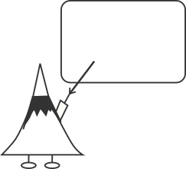
Find the latest version on www.graineahumus.org.

Introduction
This work aims to bring a general understanding of composting to the largest number of people.
We intend to explain concepts more complex with simple elements, some you might have seen before without paying much attention to it.
This document should first and foremost be recreational!
~~~
Technically, we can approach composting in many ways. It might be a chemical, biological, technical, or social approach. Understanding the various aspects allows for a better overall comprehension.
Moreover, compost can span multiple areas: waste reduction, living soil, degradation processes, gardening, garden ecosystems, eco-friendly habits…
Not to mention the social aspects of workshops and community composters. On top of helping the environment, it reduces the negative impacts on populations.
In this booklet, we will discuss subjects as contributions added to it. With our creation, it is also possible to get a format allowing for text and colors changes, as well as other types of modification.

Understanding
Key elements to understanding compost and related topics



Compost

Etymology
“Compost”, just like “composite” and “compote”, comes from the Latin compositus, meaning “composed, arranged, mixed”.
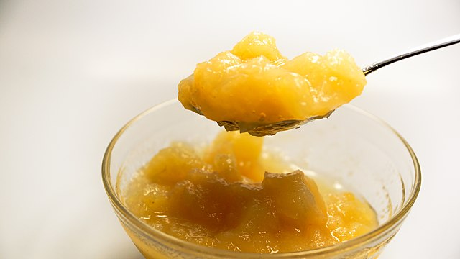
“Compote” has the same roots as “compost” (Photo from “Taken”, license CC0).

Definitions
For compost, we consider the following definition:
Compost is the aerobic (oxygen-required) decomposition of organic matter (matter produced by living things).
Without the presence of air, it is most likely fermentation that is happening: it is a different process that is used in anaerobic digestion, for example.
When talking about organic matter, we hear words like green waste, brown waste, garden waste, bio-waste…They’re not all synonyms!
Let’s discuss this more.
Firstly, in France, as shown in the infographics, about a third of household waste can become compost. Composting is of crucial importance, because it is
an environmental solution that is viable, biomimetic, and long known.
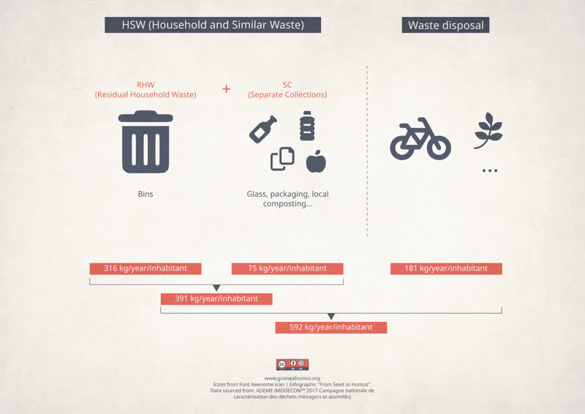
Distribution of household waste per habitant generated in France (data from ADEME, 2017)
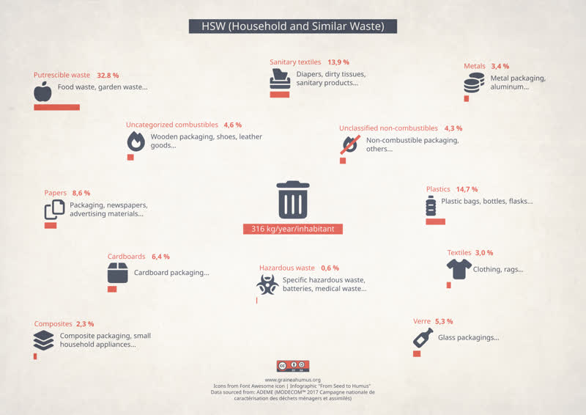
Distribution of residual waste per habitant generated in France (data from ADEME, 2017)

Organic matter
Organic matter encompasses all matter produced by living beings. That is the case for all living things: fungi, plants, insects, bacteria, mammals…

Bio-waste
Before we define bio-waste, we should define waste.
Waste has a legal definition, which varies depending on the country. In France, the Code for the environment defines waste as:
Any substance or any object, or more generally any movable property, the owner of which parts with or has the intention or the obligation to part with.

Article L541-1-1 of the Code for the environment

We could think that bio-waste is made up of organic matter, but that is not entirely true. Bio-waste is defined as:
Non-dangerous and biodegradable garden or park waste, food waste from households, offices, restaurants, wholesale trade, canteens, caterers or retail sale, as well as similar waste from food processing factories.

Article L541-1-1 of the Code for the environment

We will notice that not all organic matter are included, such as hair, nails, feathers, horns, manures, feces, urine, or cadavers.
And yet, everything can be composted, but in more specific conditions, to avoid pathogens.
Organic matter = Bio-waste + organic matter with a pathogen risk (hair, nails, feathers, horns, manures, feces, urine, cadavers…)
The organic matter with a pathogen risk can be composted as well. This brings forth fascinating subjects, such as composting toilets or humusation (the transformation of deceased bodies into humus).
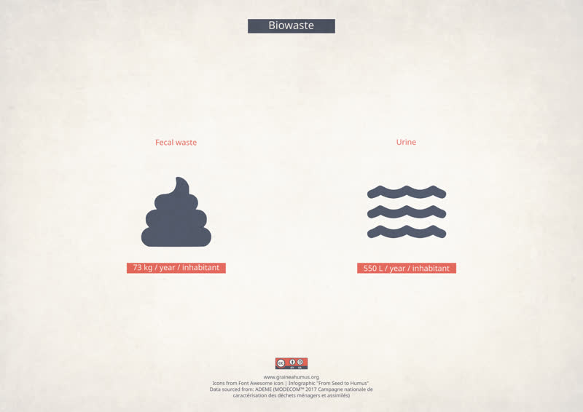
Human waste per habitant generated in Frvance (data from ADEME, 2017)

Green and brown matter
Compost is generally a mix of two bio-waste inputs:
- green matter (also called nitrogenous matter, humid matter, green input, or green waste);
- brown matter (also called carbonated matter, dry matter, brown input, or brown waste).
Green matter, such as grass or leaves, turns brown after losing its nitrogen (N), mainly to the atmosphere.

Bio-waste = green matter + brown matter

Green Materials
Green materials (also called high-nitrogen materials, undried materials or green waste) are mostly catering waste, but can also include green garden waste (like grass cuttings or fresh garden leaves). Green materials are rather moist, soft and can degrade pretty quickly.
Sometimes we use the term “green waste” to talk about garden waste generally speaking. However, they can contain branches, dead and dry leaves… which are brown waste!
You should beware of the polysemy of this word!
Moreover, when this matter is used as a resource, it is more relevant to use the term “material” instead of the term “waste”.

Brown Materials
Brown materials (also called carbon materials, dry matters or brown waste) are mainly cellulose-based or lignin-based materials.
We find carbon mainly under two forms inside the plants: the cellulose and the lignin.
- The cellulose, which is found inside the leaves, is a molecule that gives a rather flexible aspect.
- The lignin, which is found inside the branches, is a molecule that brings a quite stiff property to the material.
Thus, it includes dead leaves, crushed branches, wood chips, sawdust, bark, straw, but not only!
It also includes some derivatives of wood, like paper, cardboard, brown-paper bags, newspapers, or crushed wooden crates.
However, be careful of the additives (like chlorine, heavy metals, non-plant-based inks…) that are sometimes used in transformed products.
Brown materials are often drier and harder than green ones, and they degrade generally more slowly.

Catering Waste
Once again, catering waste are named from a legislative definition. The European sanitary regulation defined catering waste as follows:
All waste food, including used cooking oil, originating in restaurants, catering facilities and kitchens, including central kitchens and household kitchens.

Annex 1, point 22 from the European sanitary regulation 142/2011

Kitchen waste
Food waste from kitchens are waste from peelings and other food that has become waste during the cooking preparation.

Table scraps
Food table scraps are waste that are not eaten and left on plates or on the table (slice of bread not completely eaten…).

Green spaces waste
They are also called “green waste” (not to be mistaken with green or high-nitrogen material) and are vegetable waste from gardens, parks, from street, road and path maintenance, and from all other sorts of green spaces.

Others
Apart from matters with potential pathogenic risks, we find neither components like used paper napkins nor cardboard or egg boxes in catering waste…
They are also compostable, even though it is usually better in terms of environmental impact to recycle them when it is possible.
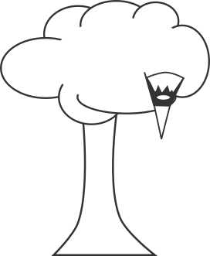
Bio-waste = catering waste + green spaces waste + other organic waste without pathogenic risk

Different Types of Compost Bins
There are many different types of compost bins.
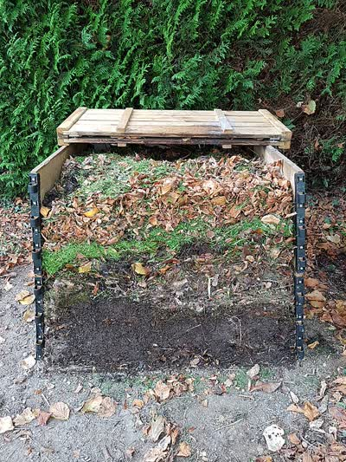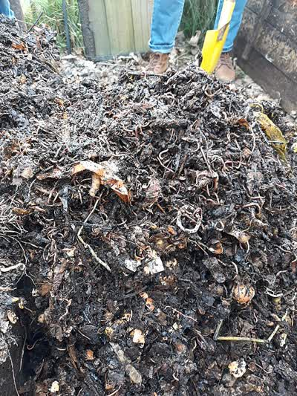
On the left, a compost pile (Picture by “Agreb44”, license CC BY SA); a backyard compost pile on the right (Picture by “Pierre.hamelin”, license CC BY SA).
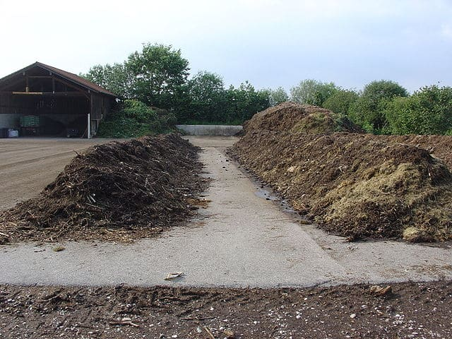
Windrow composting (Picture by “Crystalclear”, license CC BY SA).

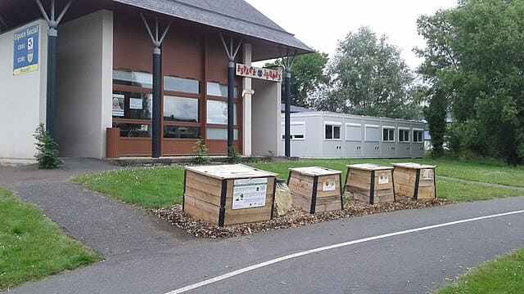
Public Compost Bin (Picture by “Compostout”, license CC BY).
We could add to this the vermicomposting, which is characterized by the use of earthworms, or the compost tumbler.

Strictly speaking, the Bokashi composting method, which uses anaerobic fermentation (without air), is not reel composting – that process being aerobic.

Compost chemistry

Respiration
Composting is the same chemical reaction as breathing.
C₆H₁₂O₆ + 6O₂ → 6CO₂ + 6H₂O + ENERGY
TRANSLATION
At the beginning (inhalation) | At the end (exhalation)
C₆H₁₂O₆ is a sugar (glucose) | CO₂ is carbon dioxide
O₂ is dioxygen present in the air | H₂O is water
| There is residual energy.

Explanations

Chemical reaction
A molecule (for example H₂O, the water molecule) contains atoms (in the case of water, two hydrogens, H, and one oxygen, O).
A chemical reaction occurs when atoms have stronger affinities when rearranging themselves to form another molecule.
There exist chemical molecules kits, showing how a molecule, an atom or even a chemical bond looks like.
In a transformation formula (called “chemical equation”), the number of atoms on the right and on the left are equal.
Indeed, there is a preservation of matter, one of the principles of physics.
“Nothing is lost, nothing is created, everything is transformed.”

Apocryphal quote from Antoine Lavoisier
Furthermore, there is also a preservation of energy (another principle of physics).
Yet, the reaction happened because the links between atoms (called “bounds”) need less energy and occur with “less effort”. Therefore, the energy present at the end of the reaction is equivalent to the one saved in the bounds. In those cases, the energy is often expressed in the form of heat.
Atom bounds are made through electrons (e-), present in atoms.
To understand this attraction, we can take a plastic ruler and rub it on a textile.
When approaching the ruler to the hair, we see the attraction happening. This is due to the electrons that have negatively “charged” the ruler, which then acts as a sort of magnet to the hair.

Sugar
To produce the respiration reaction, sugar is needed.
In the human body, all carbohydrates from food are transformed into glucose during digestion. Furthermore, some food directly contain sugar.
Put a small crumb of white bread in your mouth.
Wait for the saliva to start decomposing the bread crumb.
Its taste will change and become sweeter.

Dioxygen
Dioxygen (O₂) is present in the air.
Surprisingly, dioxygen is not the main molecule present in the troposphere, the lowest layer of the atmosphere. Indeed, it only represents 21% of the gases.
Air is composed at 78% of nitrogen (N₂). We will talk about the atom N later on.
Air is also composed of 1% of multiple gasses.
When we breathe, only the dioxygen molecules are used by our lungs; the nitrogen goes out without being used.

Carbon dioxide
Carbon dioxide (CO₂) is exhaled. It only represents 0.04% of the troposphere.

Water
Exhalation also produces water.
We can see water when exhaling with the mouth wide open on a window or on glasses.
We can also see that the more people there are in a car, the more steam there is on the windows.

Energy
Exhalation also produces heat.
When exhaling with our mouth wide open on our hand, the air is warm.
But be careful, if you make a “duck face”, the air will be cold thanks to another effect (the Venturi effect, which we will not tackle here).

Fundamental elements
Chemically, living organisms contain four fundamental elements.
- C, carbon
- H, hydrogen
- O, oxygen
- N, nitrogen (N comes from the Latin Nitrogenium)
We saw the first three elements (C, H, O) in the formula for the compost’s breathing.
N takes part in plant growth in the form of nitrate (NO₃) and is present in a complex cycle of different types of nitrogenous elements.

C/N ratio
The C/N ratio indicates the number of carbon (C) atoms compared to nitrogen (N) atoms.
The ideal ratio for a compost is between 25 and 30.
C/N is indeed a ratio. Thus, two matters that are at 30 do not necessarily the same amounts of C and N, for example.
The first can have 30 C and 1 N in a certain volume and the second twice more for the same volume, so 60 C for 2 N.
However, the ratio of the two elements will remain the same (30/1 = 60/2 = 30).

The C/N ratio varies for each element. We can easily find those values on the internet. It is often a range of average values.

Type of supply | C/N ratio
Urine | 0.7
Green vegetable matters | 7
Human feces | 5-10
Lawn | 10
Kitchen waste | 10-25
Coffee grounds | 24
Potato tops | 25
Pine needles | 30
Tree leaves (fallen) | 20-60
Plant-based green waste | 20-60
Oat straw | 50
Rye straw | 65
Cereals straw | 50-150
Bark | 100-150
Wheat straw | 150

Source: Wikipedia, “Carbon-to-nitrogen ratio” article

Carbon
Carbon has a rather simple natural cycle, as presented on the poster 1 below.

Nitrogen
Nitrogen has a more complex natural cycle, as presented on the poster 2 (page 18).
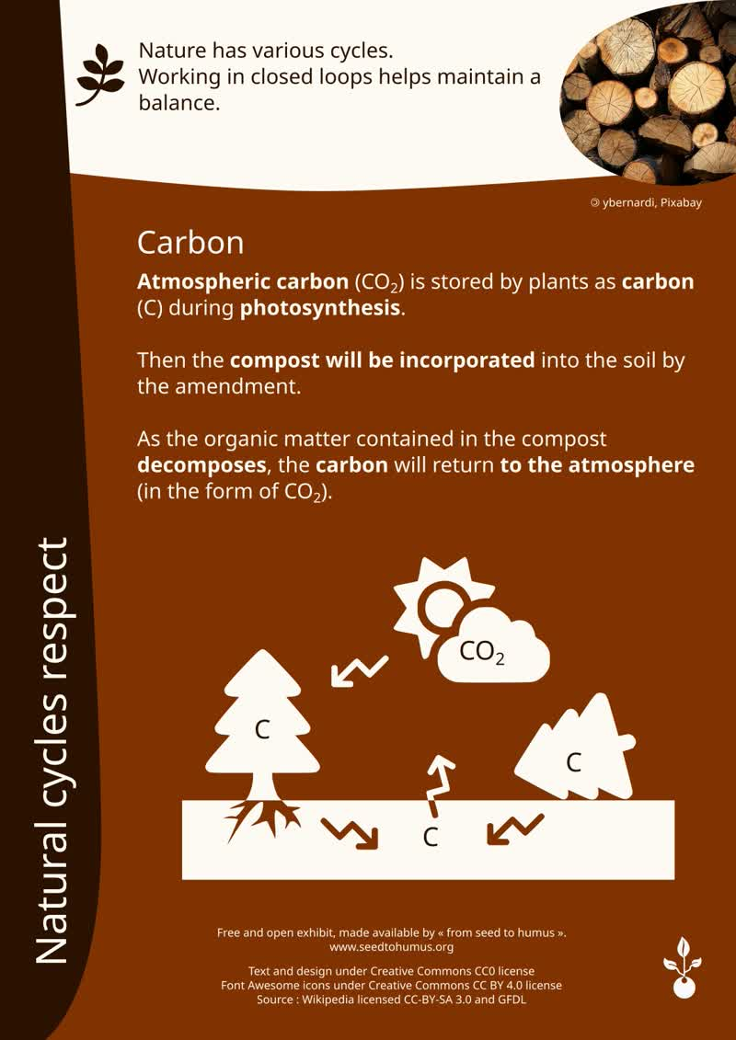
Poster 1 (« De la graine à l’humus », CC0 license).
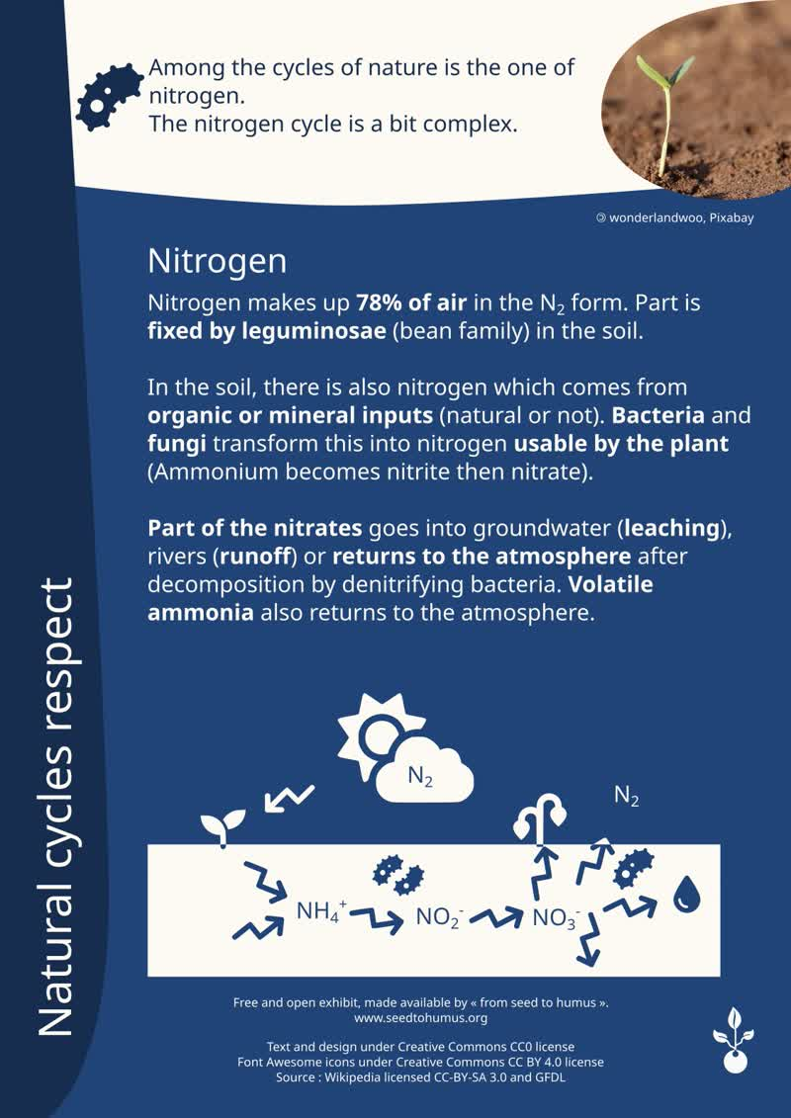
Poster 2 (« De la graine à l’humus », CC0 license).
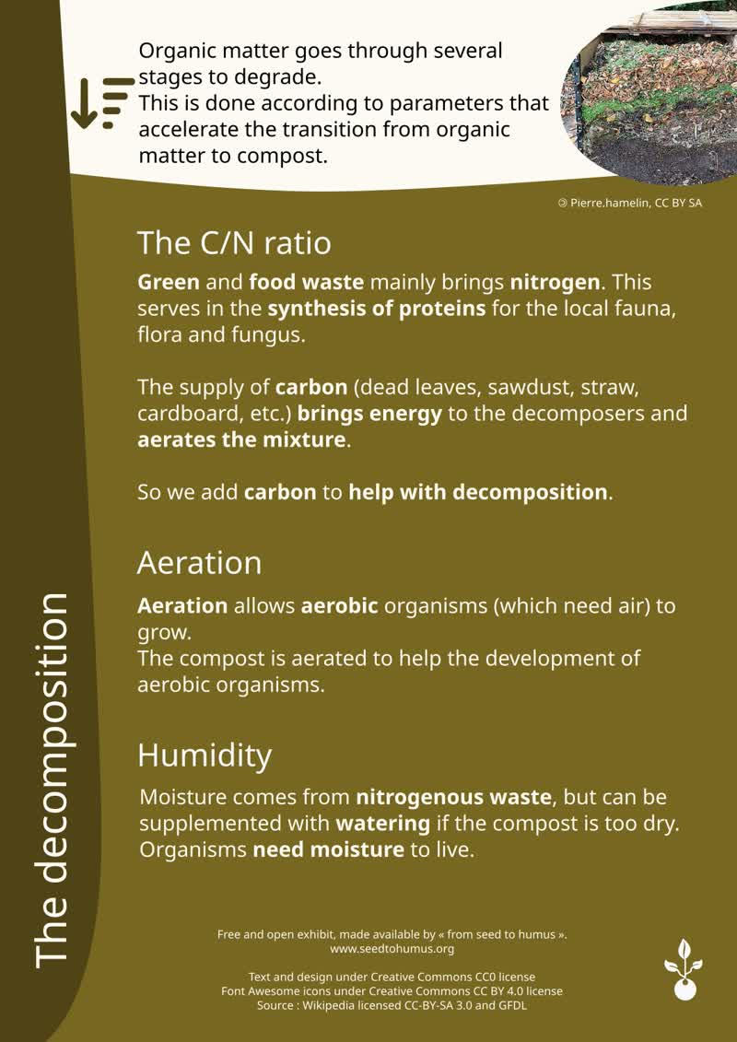
Poster 3 (« De la graine à l’humus », CC0 license).

Compost’s biology

Aeration
To maximize air circulation, you can stir and aerate the compost using specific tools, or use materials to improve its structure (e.g. ground materials that help increase air circulation).

Humidity
Humidity is also relevant so that the organisms that decompose the compost may survive. However, if there is too much humidity, the air pockets that are useful for these organisms will be filled with water.
Ideally, the compost pile or container should be placed in a sheltered spot, away from wind and rain.

Living things
The process of decomposition of matter is enabled by living beings, and causes that matter to be stirred to some extent.
Some species are attracted to carbon, others to nitrogen, and others to both. Species step in at specific moments of the decomposition (See posters 4, 5, 6, 7 and 8 on the following pages). Therefore, the compost container uses a biomimetic process.
The larger the surface area is, the more effective the decomposition is. By decomposing matter, the biggest insects (or the small mammals) enable the smaller ones, bacteria and fungi to have access to a larger area.

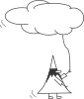
A square with sides measuring 1 by 1 has a perimeter of 4. Cut in half, the perimeter measure now 6.
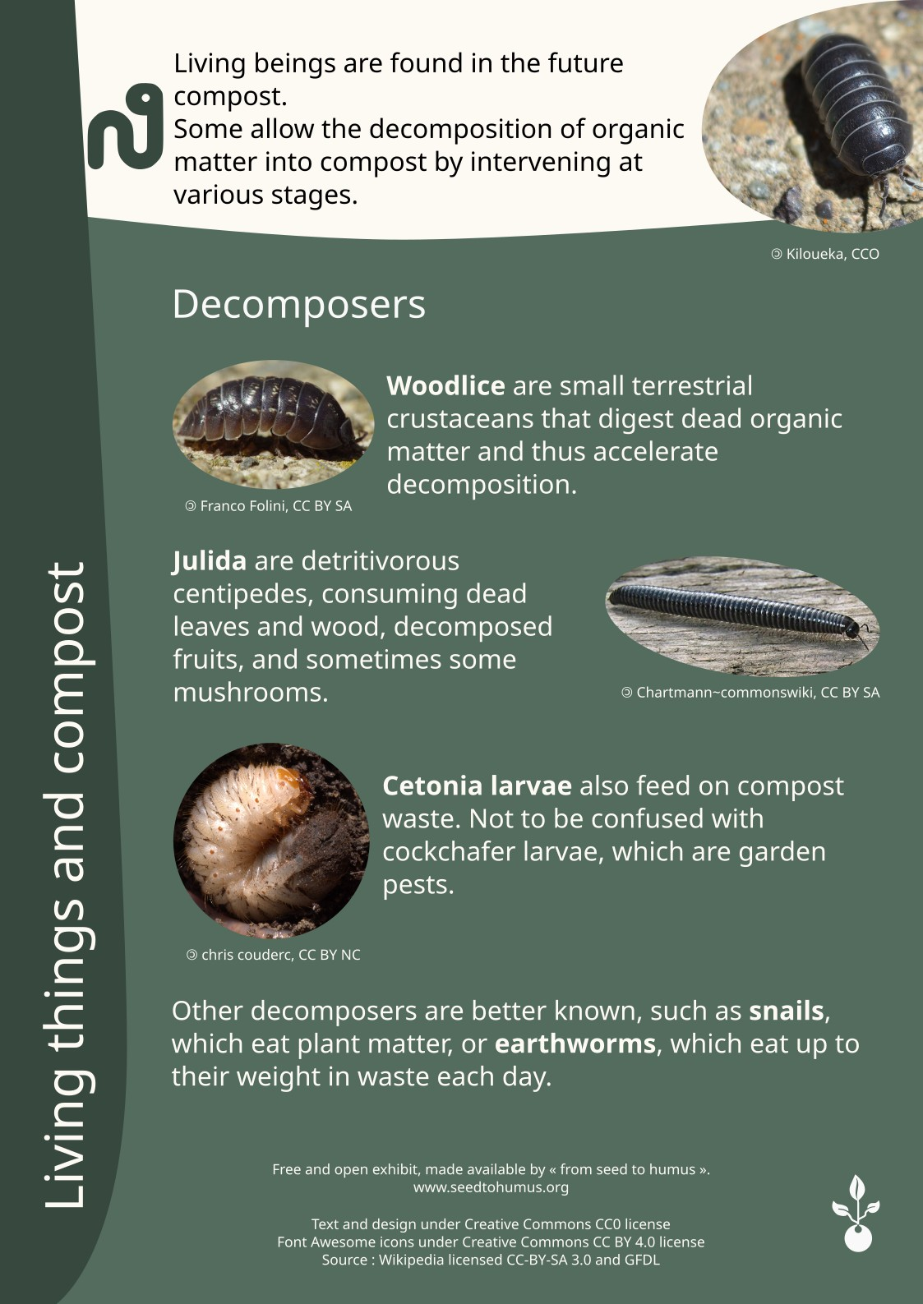
Poster 4 (« De la graine à l’humus », CC0 license).
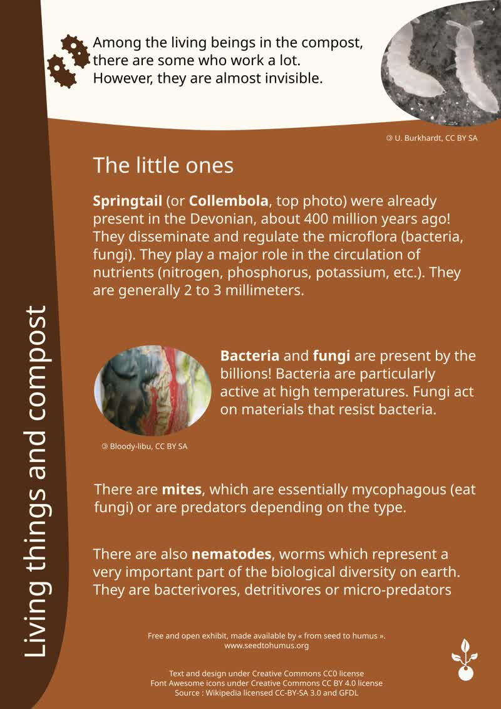
Poster 5 (« De la graine à l’humus », CC0 license).
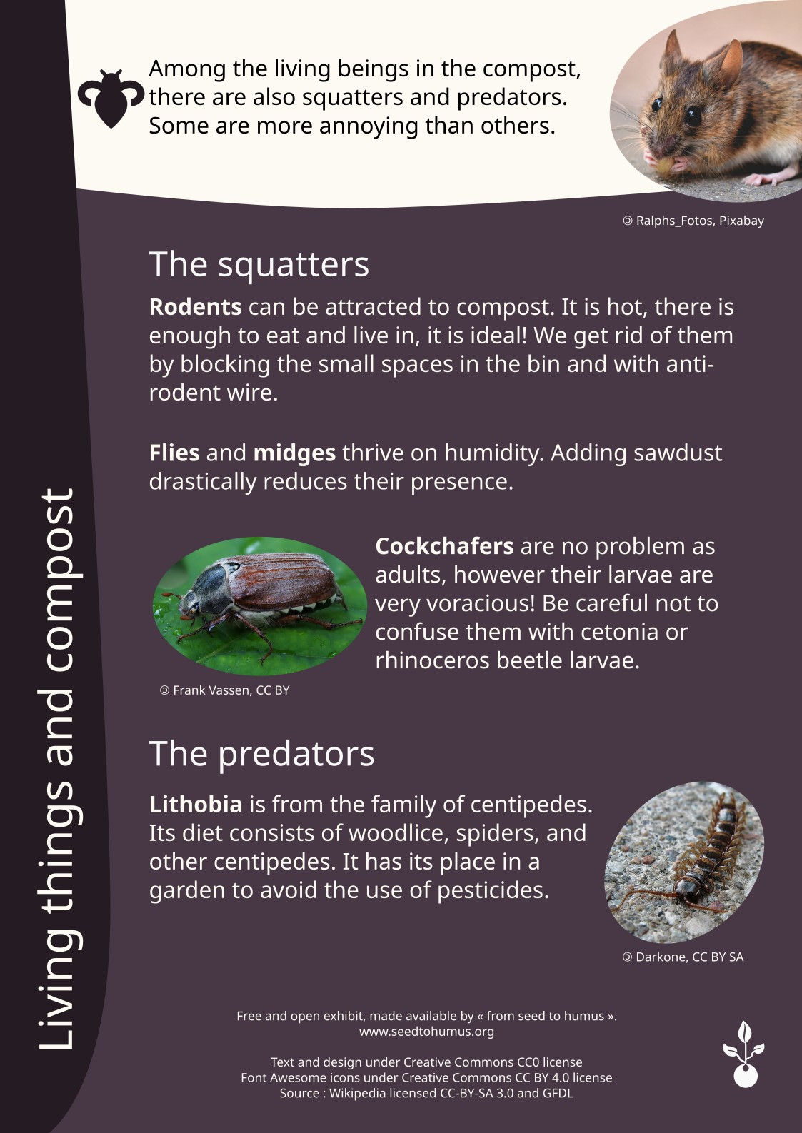
Poster 6 (« De la graine à l’humus », CC0 license).
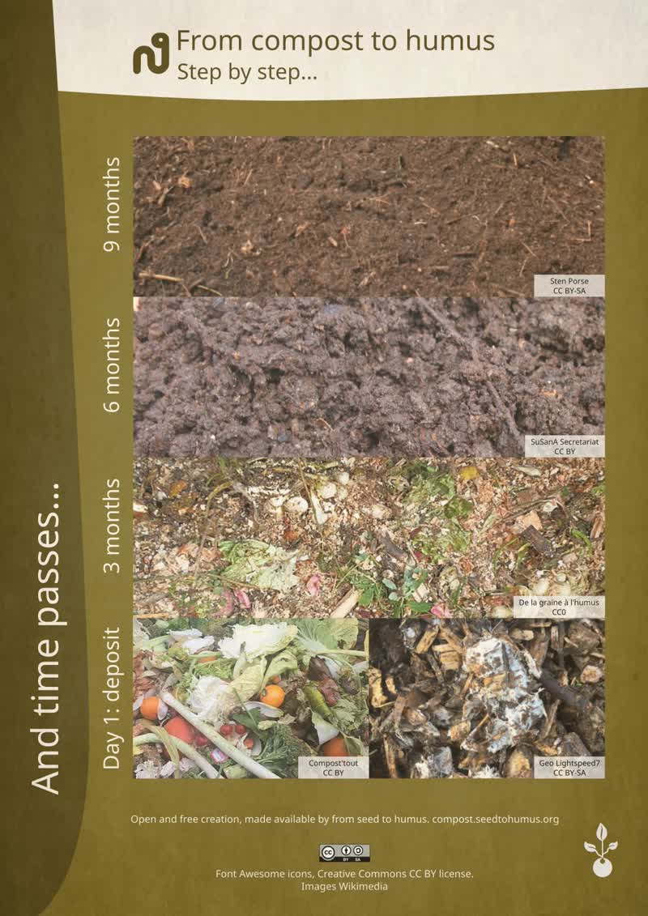
Poster 7 (« De la graine à l’humus », CC0 license).
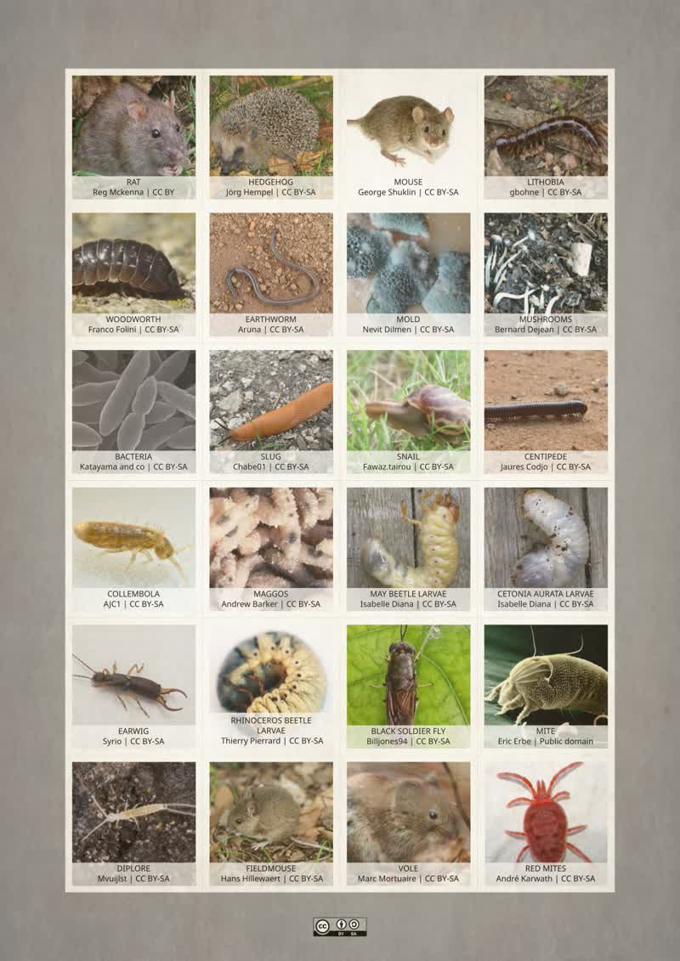
Poster 8 (« De la graine à l’humus », CC0 license).
Some species are welcome, while others are not. Below is a short list of things that a compost container can attract.

General information
A compost container swarms with life. At first, we find detritivore bugs (meaning they eat vegetable and wood remains), such as bacteria and woodlice… New stages then begin and the ecosystem changes little by little.
In turn, each of these species will act on the matter, deteriorating it, and may eventually be served as breakfast for the next “container-mate”.
One of the most important cycles in soil’s life is the production of the clay-humus complex, which holds soil nutrients and prevents runoff or leaching.
To obtain it, fungi must produce glomalin, which is then used by worms to bind clay and humus together by mixing it to form this complex. Hence the importance of diversity in a biomimetic principle.
A rich and living compost will be able to become a rich and fertile humus, which will nourish the soil over time.

The most visible ones

Rodents
Compost can attract rodents. It is warm, there is food and it is a shelter — perfect!
In addition to a wire fence at the bottom of the container to block out rodents, we should check for any possible entry points, even a small crack is enough for those little creatures to sneak in, and then find a solution. When plowing or distributing, the rodents will get scared and get away.
Before manipulating anything, make sure to “seal” any potential entry point to prevent them from returning as quickly as they left the container.

Flies and midges
Excessive humidity can attract flies and midges.
Add ground material and mix it with organic matter, it’s effective quickly.

Woodlouses
These small crustaceans digest dead organic matters, therefore accelerating decomposition. These nice compost activators are welcome!
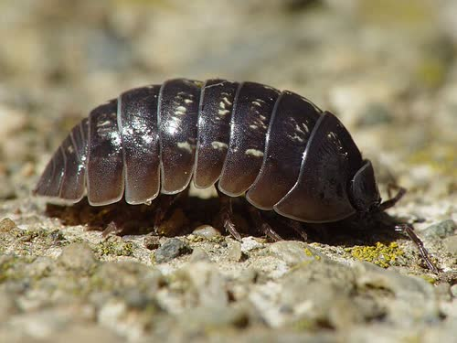
Woodlouse by Franco Folini, BY SA license.

Julida
Julida is an order of millipedes. They are detritivorous, as they consume dead leaves, woods and decomposed fruits…. They sometimes eat some fungi.
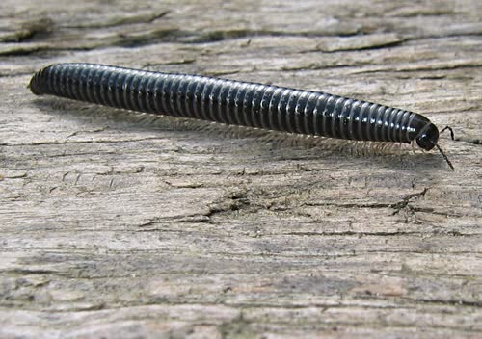
Julida by Chartmann~commonswiki, BY SA license.

Stone centipedes
The stone centipede, as the julida, is from the Myriapoda family (millipedes).
Its diet is made of woodlouses, spiders, as well as other Myriapoda.
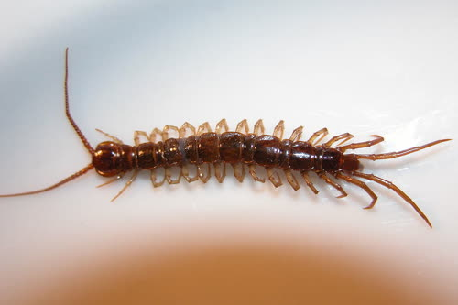
Stone centipede by Palica, BY SA license.

Earthworms
They can eat up to their own weight in waste each day, therefore accelerating decomposition.

Gastropods
The word “gastropod” comes from gastros, “stomach” and podos, “foot”, literally “the one whose foot is its stomach”. Therefore, we find slugs and snails in that mollusk order, that can come to decompose organic matter.

Cetoniidae larvae / Melolonthinae larvae / European rhinoceros beetles
Cetoniidae larvae decompose wood. The Cetoniidae, Melolonthinae and European rhinoceros beetle larvae (less common) may look alike a little.
If Cetoniidae and European rhinoceros beetles larvae are welcome, Melolonthinae larvae can be destructive in gardens, in particular on young seedlings.
Cetoniidae and Melolonthinae larvae are the most common. Here is how you can differentiate them.
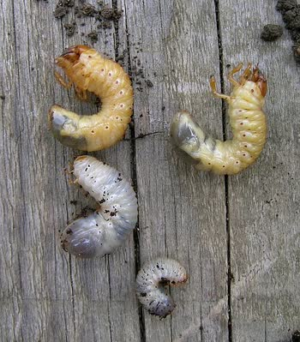
Melolonthinae and Cetoniidae larvae by Isabelle Diana, BY SA license.
The Melolonthinae larva has a big head and a small behind (at the top), the opposite on the Cetoniidae larva (at the bottom). The Cetoniidae larva is white/grey, the Melolonthinae one is yellow.

The invisible ones
Many species have a crucial role, although hardly visible.

Bacteria
Bacteria are the most numerous organisms. They proliferate thanks to the presence of nitrogen included in biowaste.

Fungi
Fungi are very varied. They appear as mold. Molds have a crucial role in decomposing plants and fermenting foodstuff.

Acarids
There are many types of acarids, such as:
- oribatids, that are essentially mycophagous (they eat fungi);
- gamasina: they’re predators…

Nematodes
Nematodes are worms that represent a highly important part of biological diversity on Earth. Thousands of nematode species could be existing. They are bacterivorous, detritivorous or micro-predators. In compost, they are generally less than a millimeter-long.

Springtails
Springtails represent around 8,000 known species in the world. They generally measure 2 to 3 millimeters.
They were long considered as primitive insects. They are apterous and ametabolous (that means they are wingless and the young larva looks a lot like the adult one).
Larvae shed their skin four to five times before becoming sexually mature. Springtails were already there during the Devonian, around 400 million years ago, which means they were there before insects.
They contribute to disseminating and regulating the soil’s microflora (bacteria, fungi) and play a major role in the circulation of nutrients (nitrogen, phosphorus, potassium, etc.), thus ensuring the availability of nutrients essential to plants.
If these animals were absent, a great amount of elements would stay immobilized within the microbial biomass: they eat away the microflora
that stimulates microbial populations, and, as a consequence, the mineralization of the soil’s organic matter.
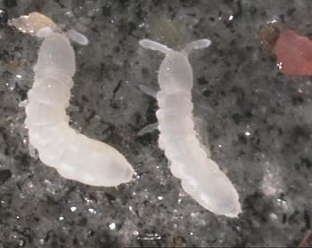
Springtail by U. Burkhardt, BY SA license.
The following graphs are specific to one scenario. There are variations according to the climates, places, types of composting, types of sediments... However, curves are quite representative of a collective composting.
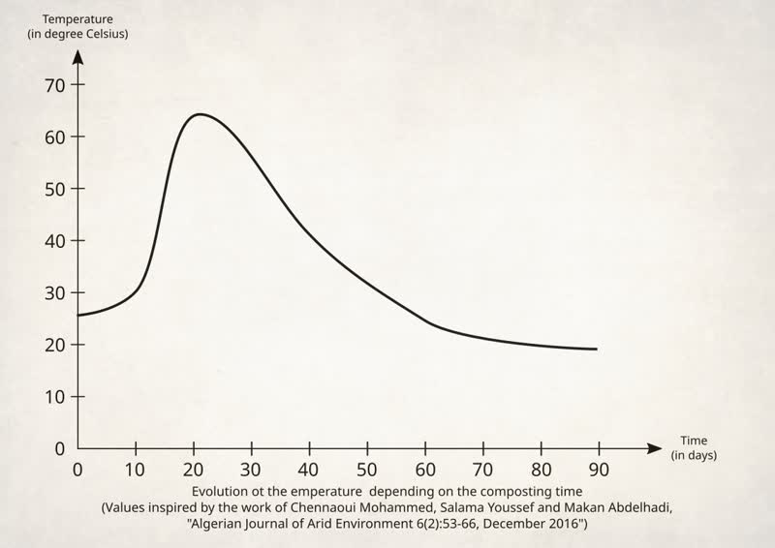
Taking the temperature is done at the heart of the compost with a compost thermometer.
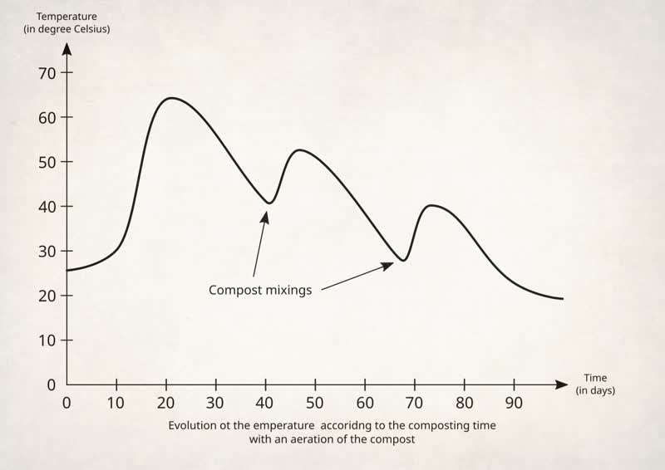
Stirring reactivates the activity of heat-producers microorganisms.

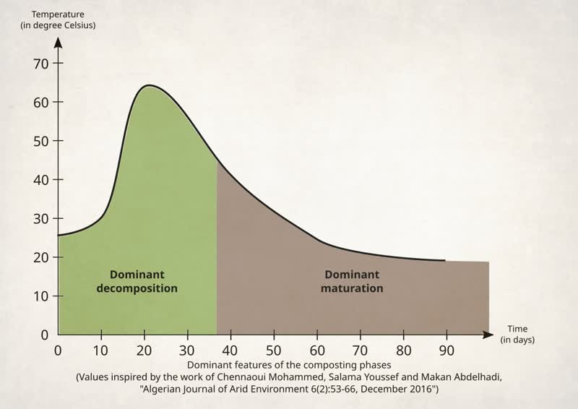
Depending on the temperatures, there are dominants in decomposition or maturation.
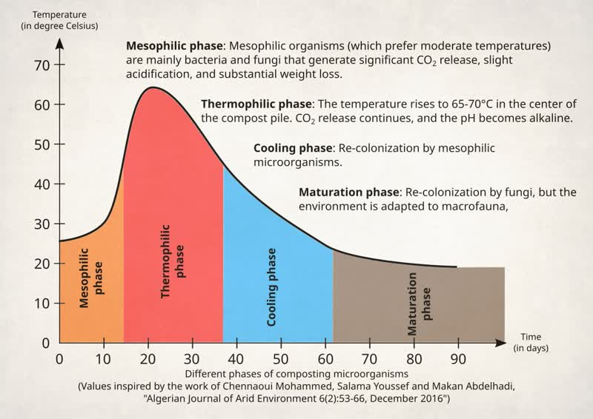
Depending on the phases, the microorganisms that are there are not the same. Some have a better heat resistance. They also don’t behave the same way.
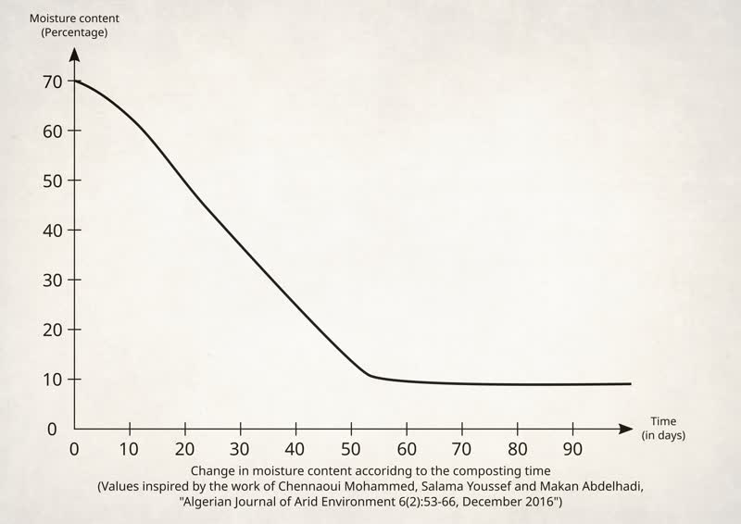
There is a high humidity rate loss with time, which generates a weight loss just as consequent.
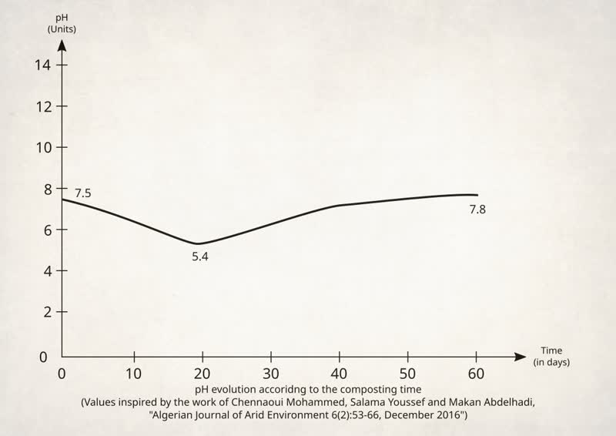
The pH acidifies during the first weeks, no matter the provisions, then neutralizes with time with a tendency to become slightly alkaline.
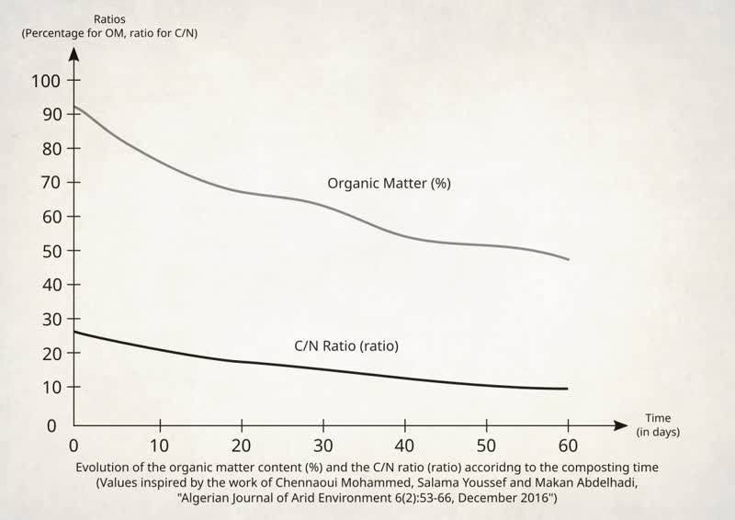
The organic matter reduces with time, as well as the C/N ratio. In fact, a good amount of the carbon evaporates as CO₂.
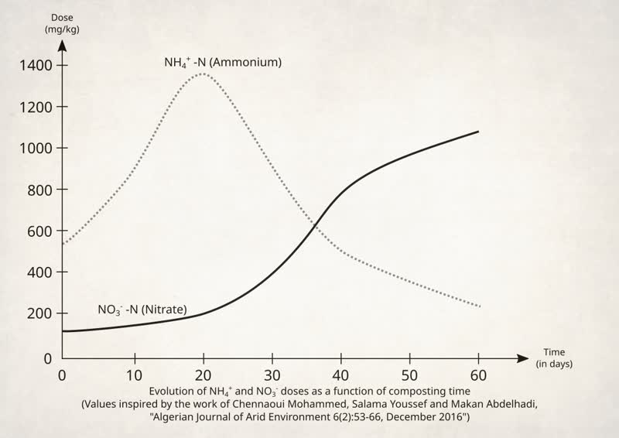

Ammonium ions let their place to nitrate as time progresses.

Compost and humus
In a compost, you ideally want to end up with a humus.
Humus is a rich living material that is crucial for holding nutritional elements.
Humus
Dark color, soft and lumpy texture, nice smell (forest-like smell).
Mineralized matter
Very thin particles containing few living organisms.
Decomposition of the organic matter in a compost
Obtaining a humus will allow the creation of a clay-humus complex that preserves the nutrients for the plants and the bacteria in the soil. As for a mineralized matter, it tends to stream and leach (see the poster 11 page 46). The dependence on imported nutrients is very important in France.

Clay-humus complex
The clay-humus complex (see the poster 11 page 46) retains the nutrients in the soil. Let’s detail the steps of the formation of this complex which allows the preservation or the restoration of soils.

Fungi and glomalin
First of all, some fungi produce a protein, the glomalin, which is excreted by the roots. We will encounter this protein a little bit later…

Humus and clay
Humus can bind with clay to act as a “nutrients magnet”.
However, clay and humus are negatively charged and do not attract.
Ions (atom or group of atoms) are indeed negatively or positively charged and thus, opposites do attract, just like magnets.
- Negatively charged, the ions gain one or several electrons (e⁻). We speak of anions.
- Positively charged, the ions gain one or several electrons (e⁻). They are known as cations.
When inserting a positive element between the clay and the humus, it is possible to associate them.
Humus (-)
Clay (-)
Clay (-)
Clay (-)
Ca (2+)
Ca (2+)
Ca (2+)
A classic method of binding humus to clay is through calcium (Ca²⁺). There are other means, like with iron hydroxide (III) Fe(OH)3. The humus can also cling on several positive charges located on they clay’s breaking points.
The association of humus and clay is called clay-humus complex and has generally a negative charge. The fungus’ glomalin acts as a binder that reinforces this complex.
Humus (-)
Clay (-)
Clay (-)
Clay (-)
Ca (2+)
Ca (2+)
Ca (2+)
Glomalin
The glomalin acts like a “glue”.
Humus (-)
Clay (-)
Clay (-)
Clay (-)
Ca (2+)
Ca (2+)
Ca (2+)
Glomalin
Clay-humus
complex (-)
To simplify, we will now note the clay-humus complex as indicated hereinabove.
As the clay-humus complex is negatively charged, it will attract positive elements. Because they are attracted, they are not going into water tables or rivers, but are used locally as nutrients tanks.

Clay-humus
complex (-)
Ca (2+)
NH4 (+)
NH4 (+)
Mg (2+)
K (+)
H (+)
Ca (2+)
The cations are attracted by the negatively charged clay-humus complex.
PO4 (3-)
Clay-humus
complex (-)
Ca (2+)
NH4 (+)
NH4 (+)
Mg (2+)
K (+)
H (+)
Ca (2+)
PO4 (3-)

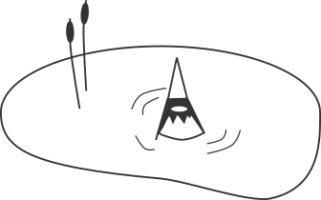
The peripheral cations can then attract negatively charged anions.
Unlike sand or silt, clay is shaped as strips. These two other soil components look like grain.

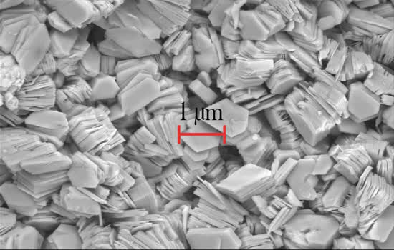
Clay seen under a microscope (“Paedona”, BY-SA license).
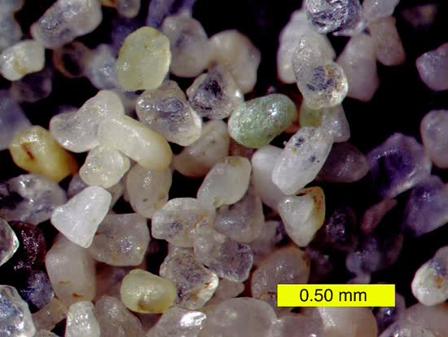
Sand seen under a microscope (“Mark A. Wilson”, BY-SA license). Though smaller, the silt also appears as grains.Types of soils

Types of soils
To know your soil means to know its texture, its pH, its water-retention capabilities, its homogeneity in terms of spatial distribution, the plants growing in it, the living things you found there, its bearing capacity, its yearly evolutions…
This allows:
- to put plants that suit there;
- to see if moving towards a culture that needs a soil close to the existent one is possible;
- to help the soil, in itself, to be more living;
- to modify it (slowly or fast);
- to decontaminate it;
- to protect or preserve it;
- to use it as a material (raw earth, rammed clay, cob, pottery...);
- to use it as a support (duck pond, building...).
That way, you can have more adapted practices to minimize the work and/or maximize the living things.

Components
Soil is a primordial resource, whose creation process is intrinsically linked to the creation of planet Earth and the development of the living things upon it. Acknowledging it can help respect this resource.
We will discuss this aspect in the annex “Earth and earth”.

Structures
There are three soil textures that influence its structure.
Clayey soil: heavy, compact, crackles when it dries, heats up slowly.
Silty soil: soft to touch, powdery when it dries, rich in organic matter.
Sandy soil: light, the soil squeals when rubbed between two fingers, heats up quickly, doesn’t hold water, poor in organic matter.
In reality, the soil is often a mix of these three types.

The jar test
To know the texture of your soil, you can do the jar test.
- Take dirt (around the equivalence of a handful) at a depth of around 10-15 cm.
- Place it in a jar after the big chunks are broken.
- Add water into the jar, approximately up to ¾.
- Shake it vigorously.
- After 30 minutes, stir with a spoon. If there is any remaining chunk, shake again so that everything is in suspension.
- Repeat the process until there isn’t any chunk left.
- Let the mixture decant for 24 h.
- Three layers are formed: the sand at the bottom, the silt in the middle, and the clay at the top.
- Measure the total height of what has decanted and the height of each layer.
- Use a cross-multiplication to get the percentages of each texture.
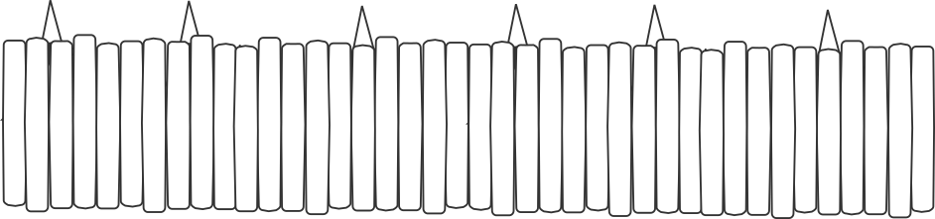
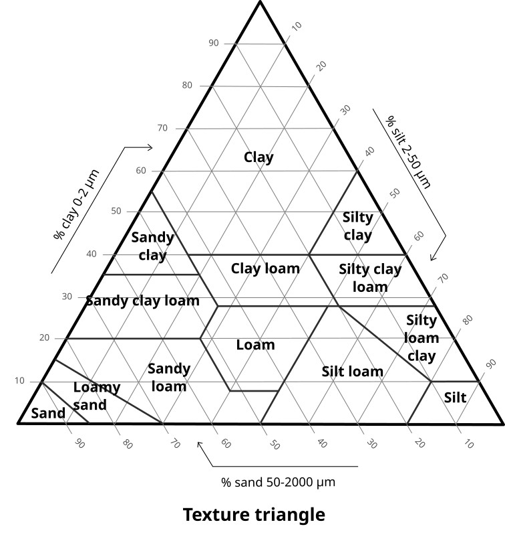
When you report the results of the jar test in the triangle of textures, you can know your soil a bit better (“Benitronne” diagram, CC0 license).
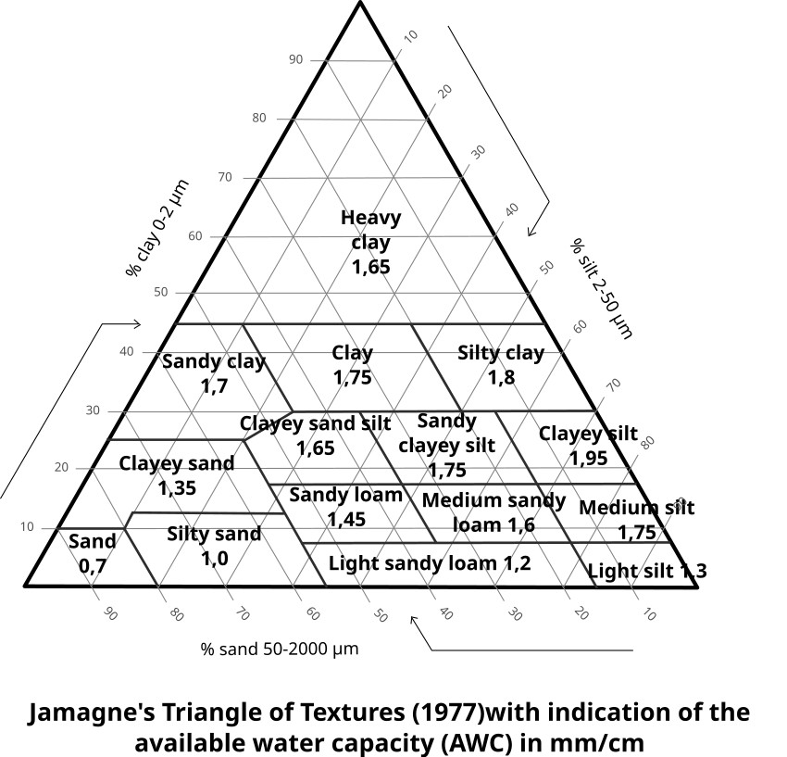
They are different representations of soil textures. This one shows the water storage capacity (diagram from “Florent Beck”, CC BY SA license).

Compactness
Different tools can be used, such as the Visual Evaluation of Soil Structure (VESS), that can easily be found online.

pH
The soil pH (see poster 10 on page 45) also limits what it can welcome.

Organic matter
The organic matter quantity (see poster 10 on page 45) is an other limiting factor.
This matter can be found, among others, on top of the soil, in what is called the “plant litter”.

Bioindicators
If the soil has similar visual features (present plants and homogenic plant distribution…), it then gives information on the soil characteristics.
Recognizing plants. You can use apps, books, online forums based on photographs… You can also reach to more expert friends or get training!

pH
Every plant grows with a specific pH level (acidic, neutral or alkaline). Endemic plants (the ones naturally present) can be identified and their pH level can be found. The scales of viable pH levels for a plant can be easily found online.
For example, if a plant growing with a pH within 5.5 to 6.5 and an other plant with a pH between 6.0 and 7.5 on the same area, then the soil pH is between 6.0 and 6,5, so slightly acidic.
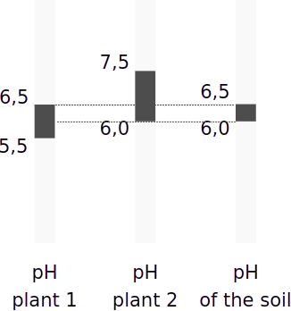
The soil’s pH falls in the pH range of the plants in it.

Type of soil
Likewise, every plant grows on a specific type of soil. We can identify and know if the soil is clayey, sandy, silty, calcareous or humic. We can also see if the soil is compact or airy, has few or many nutrients (and which ones)… Databases on different types of plant according to the types of soils can easily be found online.
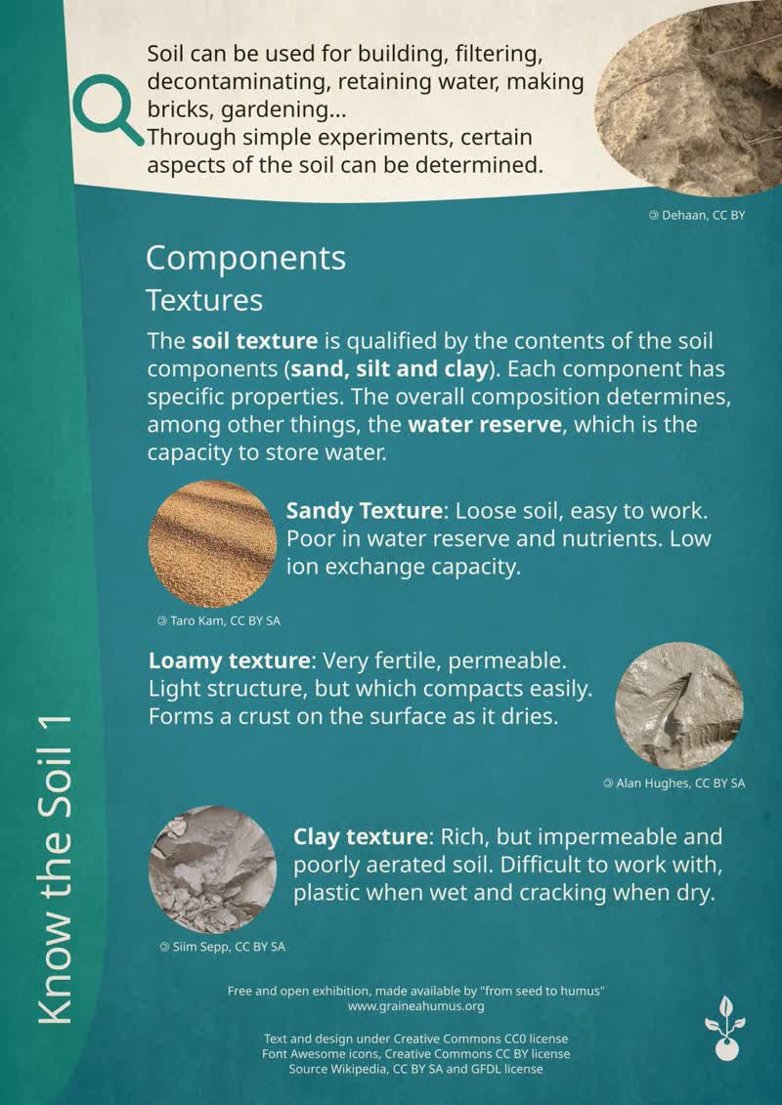
Poster 9 (« De la graine à l’humus », CC0 license).
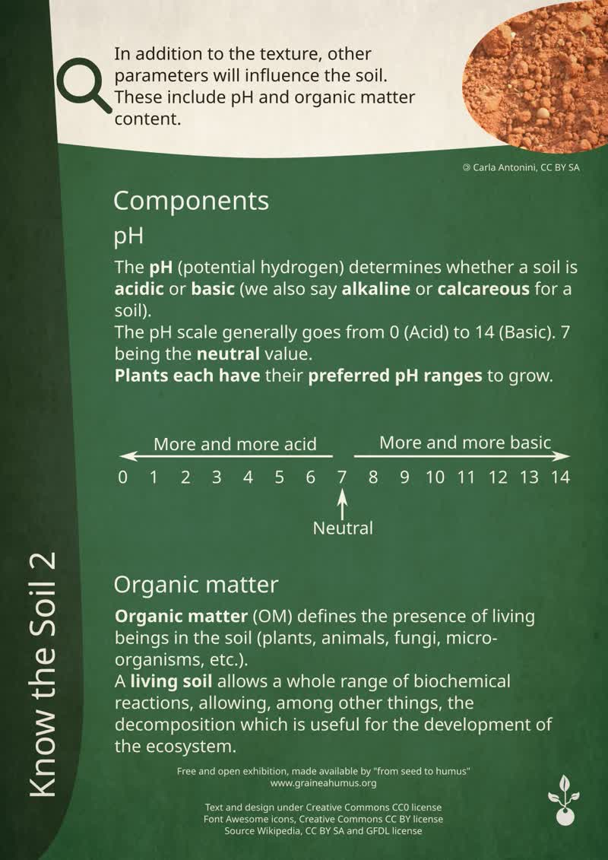
Poster 10 (« De la graine à l’humus », CC0 license).
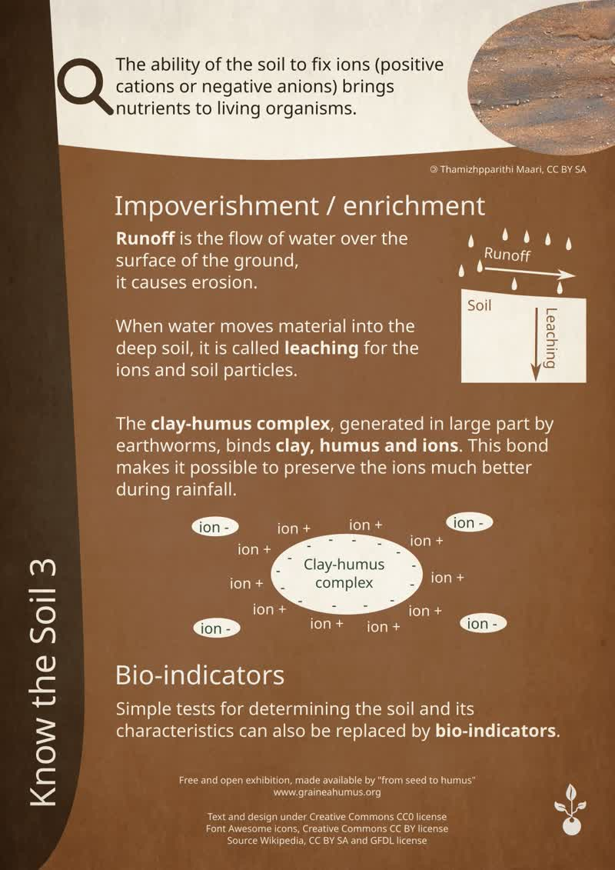
Poster 11 (« De la graine à l’humus », CC0 license).
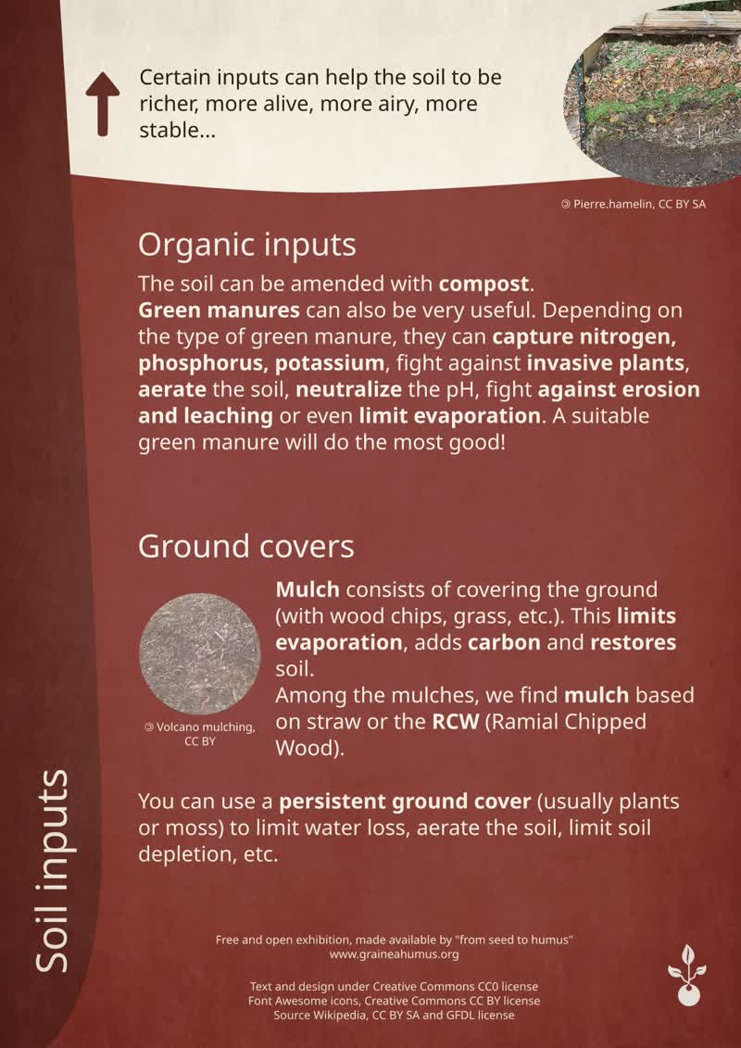
Poster 12 (« De la graine à l’humus », CC0 license).
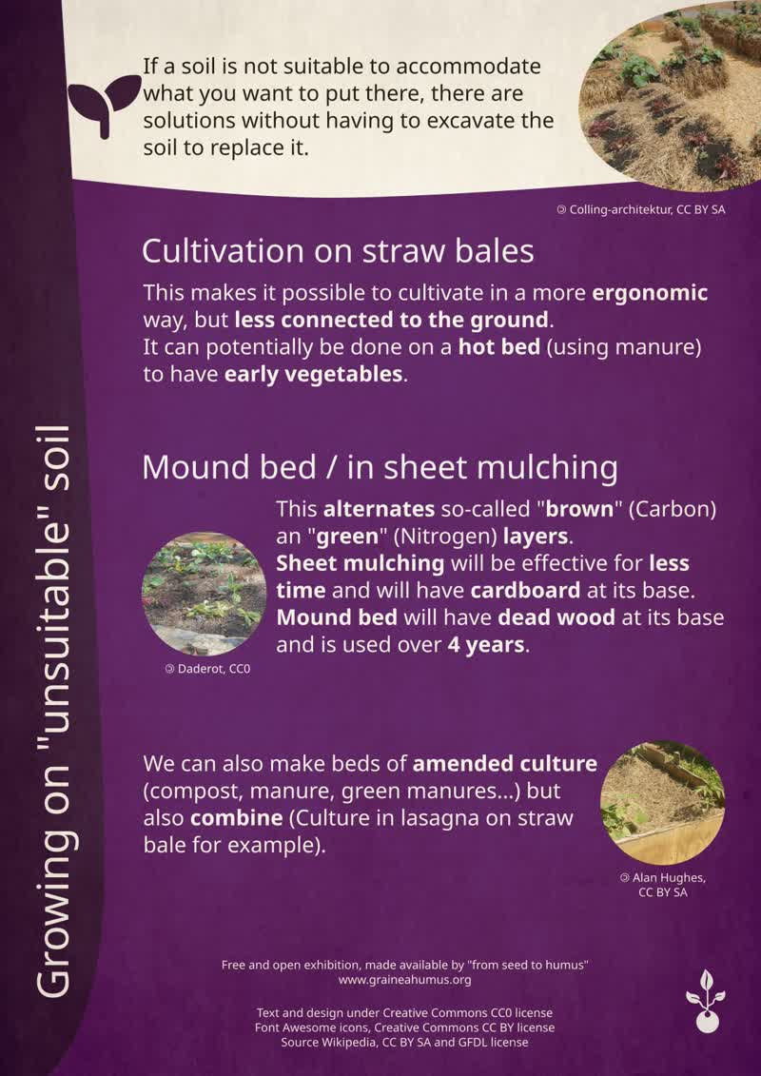
Poster 13 (« De la graine à l’humus », CC0 license).
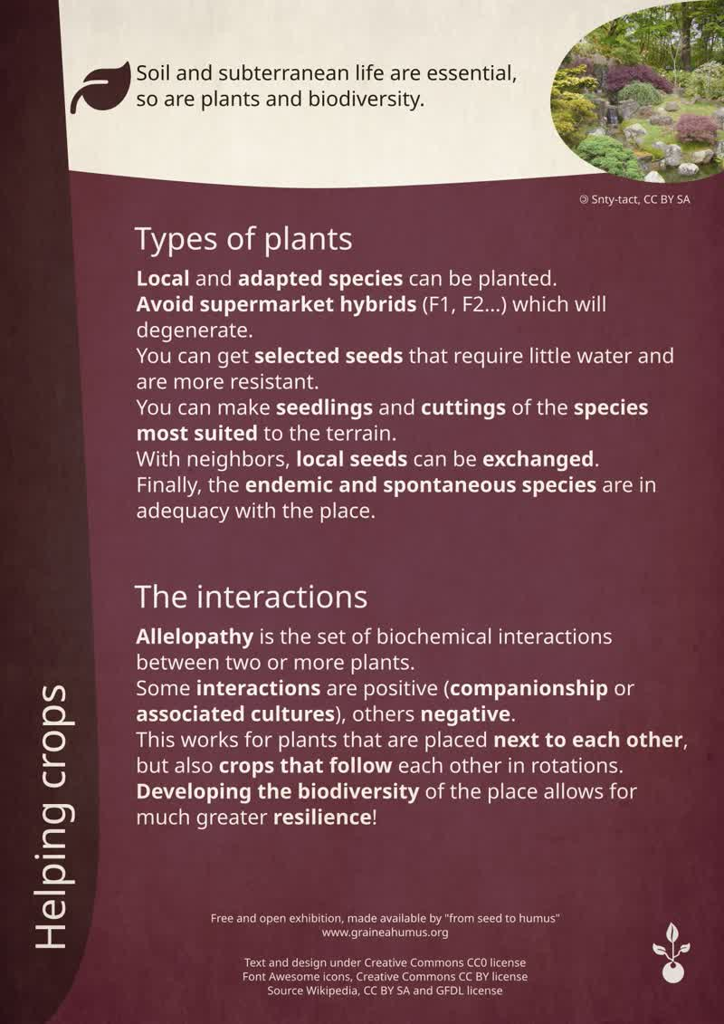
Poster 14 (« De la graine à l’humus », CC0 license).

Act
Managing compost on a daily basis

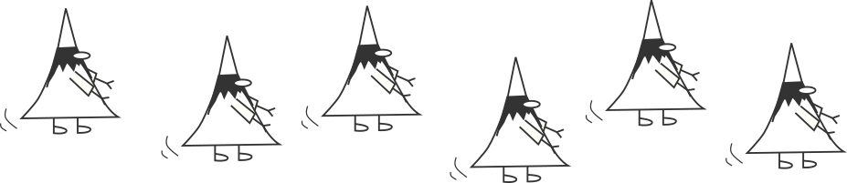


Daily

Principal

Gathering
All organic matters can be composted (egg shells, citrus, fish bones…), but there are some limitations. Some of these limitations are legal. In France, for example, it is forbidden to put some animal by-products (ABPs) in a shared composter.
Other limitations are from biological grounds, in order to not suffocate the composter which needs to be airy (with large quantities of sawdust for example).
Lastly, when using dry toilets, it is recommended to have separate piles, as the compost maturing periods are not the same.
Catering waste are put aside, ideally in a hermetic container, to avoid midge. This container should be made in an adapted material (such as ceramic, food-grade plastic…).
It is advised to cut the waste in pieces in order to accelerate the decomposition process. For example, a banana peel can be cut in three parts and an apple in four.

Limiting the number of people
When it comes to a shared composter, limiting the access to a certain amount of people (with a code-lock) can be useful:
- to get the code, one would have to contact members who would be able to give instructions;
- the size of the composter can handle a given capacity. If it cannot hold the given capacity, a second composter will be needed. Thus, we can avoid exceeding this capacity.

Sharing compost monitoring
When it comes to a shared composter, besides it being a friendly moment with discussions, monitoring it (even 30 minutes or an hour per week) enables to ensure the respect of the sorting rules.
The future actions can also be discussed (potting soil distribution, soil plowing, ripening process, the use of an other bin…).

Bins
It is advised to have at least two bins: one for filing and one for ripening. A dry matter is also available. Two ripening bins are often used when it comes to shared composters.
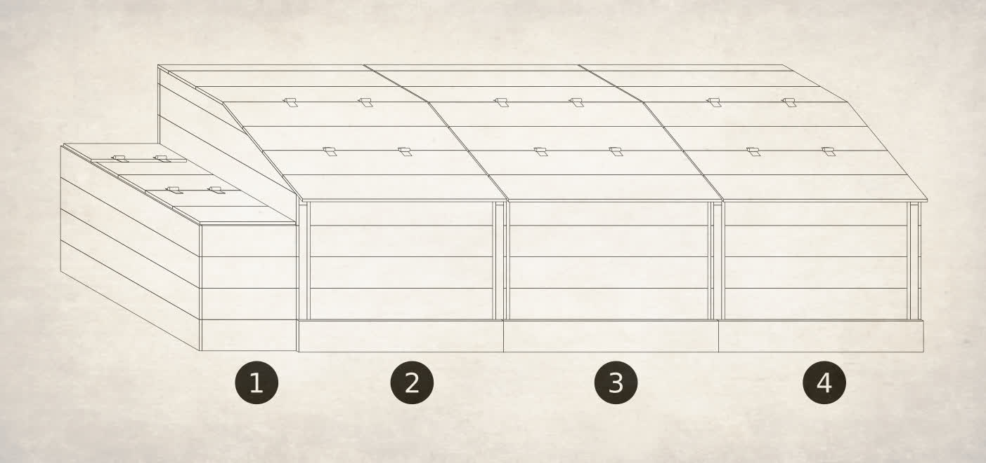
For example: a bin with a ground material, a filing bin and two ripening bins.
One the previous image, a ground material bin (1) is shown, and it is a ground material from wood. The filling bin (2) is here to collect the materials. The ripening bins (3 and 4) allow the composter to complete its processing.

Ground material
Wood chips as a ground material are an ideal supply to a shared or individual composter, which is useful for catering waste.
When it comes to ground material, it is called structuring layers, as it is airy and therefore helps the decomposition process by feeding the bacteria.
Thin matter, such as sawdust, requires to aerate better the composter. Though it can be used, it conglomerates easily, creating anaerobic conditions (with no air).
Leaves can suffocate the composter if they are not decomposed and layered well enough. When using leaves, they should be well embedded and the composter should be aerated more than usual.
In practice, when you do not have ground material, you can use dry leaves, mowed grass or even sawdust (with a moderate ratio).
The thinner the particles are, the more air the composter requires.
Blends of carbonated inputs can be used, with ideally as much as structuring layers as possible.

Filing
Green waste are put down first and then completed with brown ones. It should be unpacked if needed and well blended (with a shovel, a garden claw, a fork, or a hoe…).
In addition to green waste, brown ones are used. Wood chips as ground material are perfect for a composter. Use one bucket of nitrogen waste per bucket of wood chips.
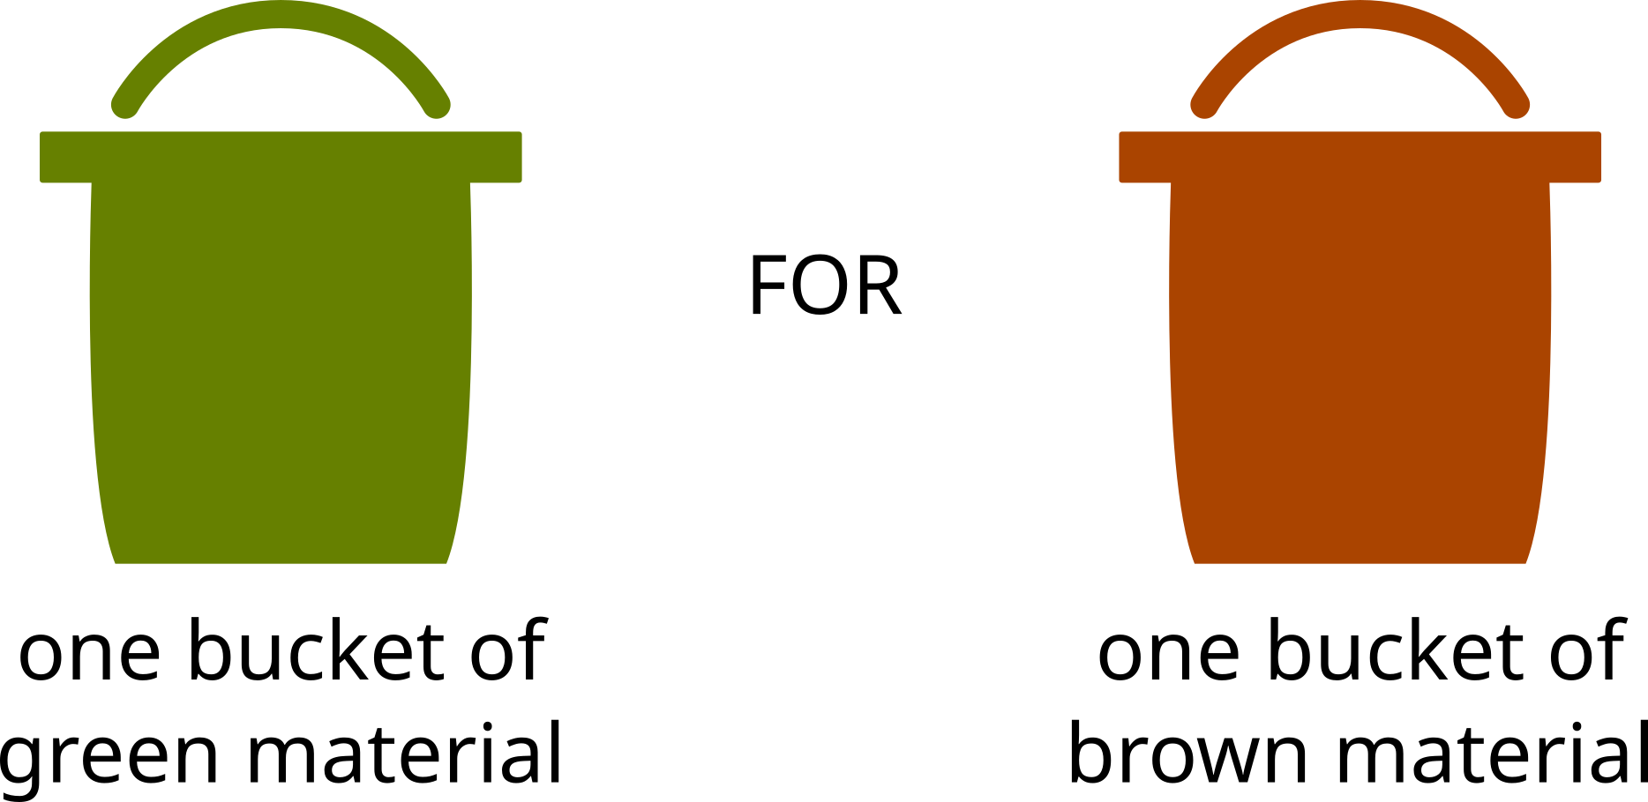

If necessary, only one bucket of nitrogen waste can be added for half a bucket of brow waste, but nor less.

Maturating process
On the drawing of a composter, once the filling bin is full (2) – preferably after approximately 3 months of use – it should be transferred into the maturing bin (3). This step is called “plowing”. If the maturing bin (3) is full, it is transferred into an other maturing bin (4). When this one is also full, then the compost should be mature and ready to be used.
After 9 months (in Metropolitan France), the compost is considered mature if it was well taken care of. It should have a dark color, a soft and lumpy texture, and a nice forest-like smell.
It is possible to use it six months in for specific needs, when it is still pretty new but not entirely decomposed.

Location
Some location criteria are related to the decomposition conditions, and others are related to practical issues.
Regarding ideal conditions for the compost development, it is advised to have a correct humidity level:
- If it is too humid, the water will fill the space occupied by the air and prevent the aerobic reaction.
- If it is too dry, the compost won’t allow living things in which are essential to decomposition.
The humidity from the greens and from the air can be sufficient for the good development of the composter.
So that the humidity is not too variable, we can:
- put the compost away from the prevailing winds drying it (at the foot of a wall or a bushy hedge, or surrounded by buildings);
- protect it from the sun and the rain by covering it (placing it under a tree or putting a lid on it);
- limit gaps when using containers (which also keeps rodents from coming).
Ideally, it should always be accessible and near the production places (gardens, kitchens…).

Sizing
For 10 homes sharing a composter, one cubic meter of space is needed with maturing bins (not including ground material).
Depending on the food habits, the size can vary between one home or one person to another.
It can be a good idea to weigh the quantities on a one-month span to know how big the composter should be.
There are average values for diverse types of eating.

Average values

Kitchen and dining table waste (density)
Public | kg/L | Source
Everybody | 0.67 | Composter guide training “au ras du sol” (at ground level)
The density for kitchen and table waste is 0.67 kg/L.
1 m³ contains 1.000 liters. Or a weight of 670 kg for 1 m³.
Keep in mind that once the kitchen and table waste are in the composter, they lose up to ⅔ of their volume due to evaporation.

Ground material (density)
Public | kg/L | Source
Everybody | 0.33 | Composter guide training “au ras du sol” (at ground level)

The density for ground material is 0.33. 1 m³ contains 1.000 liters. Or a weight of 330 kg for 1 m³.
Ideally, ground material should not be stored for more than 6 months.

Kitchen and dining table waste (volume)
Public | Area | Source
Citizens | For 10 homes sharing a composter, one cubic meter of space is needed with maturing and deposit bins (not including ground material). | Composter guide training “au ras du sol” (at ground level)

Kitchen and dining table waste (weight)
Public | kg/year/inhab | Source
Citizens | 40 to 50 kg | Composter guide training “au ras du sol” (at ground level)
Citizens | 83 kg of putrescible waste (mainly food) for 254 kg of residual househould waste | “Déchets chiffre clé, l'essentiel” 2019 (“Waste, key numbers: main information”). From the ADEME (page 7)

We can consider 40 to 50 kg per inhabitant per year. It can go up to 80 kg by person.
Public | kg/year/inhab | Source
Institutional food services | 134 g/meal for other collective catering areas (production + distribution) | Approximate study of biowaste production in the food service industry by the GNR (National Group for Restauration) and IDE ENVIRONNEMENT
Institutional food services | 11 g/meal made for central production kitchens
Institutional food services | 125 g/meal distributed for satellite food services
Institutional food services | 140 g/meal for theme restaurants and traditional cuisine
Institutional food services | 43 g/ticket for fast-food services (for all areas)

Preparation of the terrain
If you decide to use trays, the terrain must be flat.
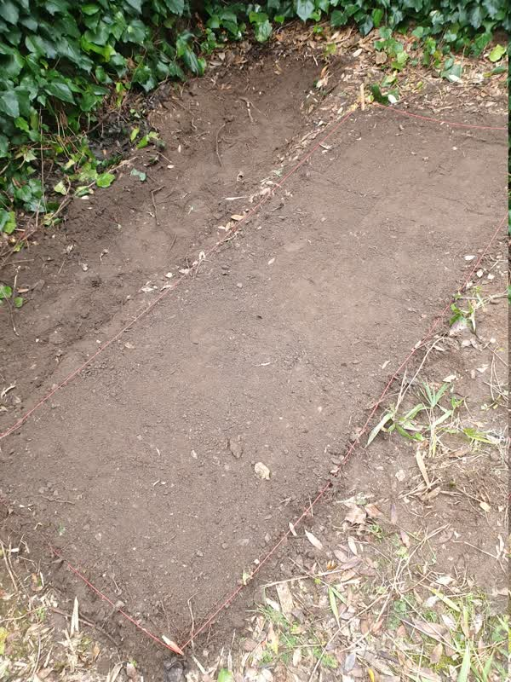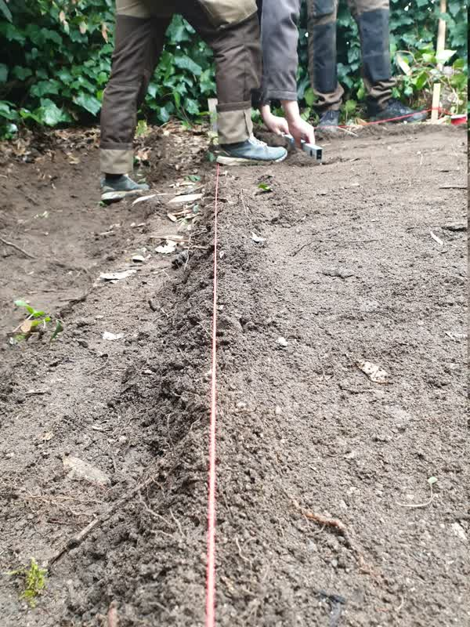
Start by mapping out the compost location with guiding lines. The best would be to raise the soil where the trays are. Compress the soil to stabilize the location.
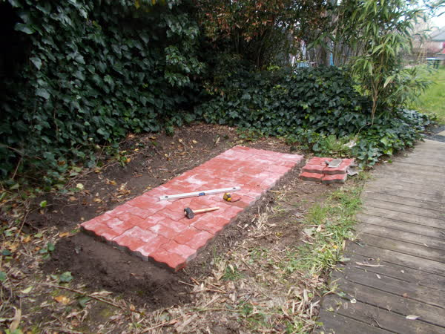
You can put pavers to prevent rodents from coming. You can also buy wire fences to block out rodents.

Materials
The materials must resist to outdoor weather.

Metal
Every piece should be stainless steel to be used outside.

Wood
Choose Use Class 3 wood and do not place the wood directly onto the ground. Choose an untreated wood, like Douglas wood. Woods from pallets, like “EPAL Euro” pallets, are made with rough timber and are not chemically treated. On the side, there are different mentions such as the HT marking for Heat Treatment.
Not all pallets are Use Class 3! Look out for the HT markings on pallets like the EPAL Euro ones.
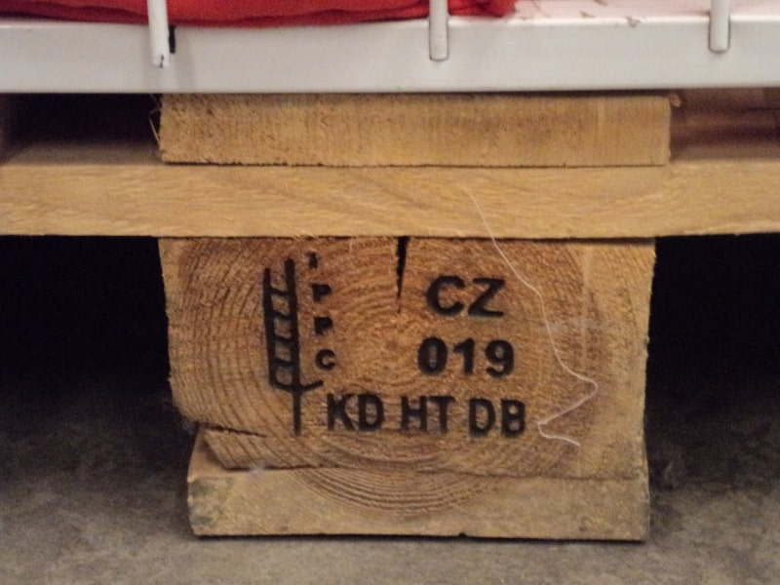
Pallet bearing the HT marking (Picture by “Oaktree”, Free art license).
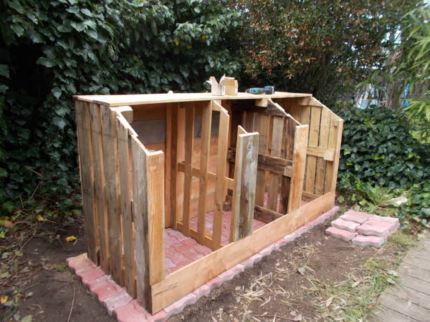
Compost container made with pallet wood and second-hand Douglas wood.
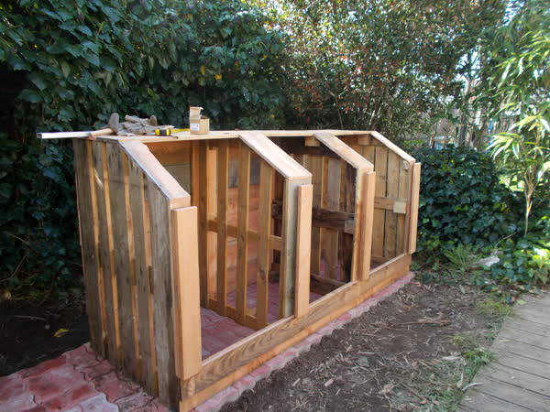
Runners between each containers so as to easily put in or take out planks and simplify its use. At the bottom of the runners, there is a stop that holds the planks.
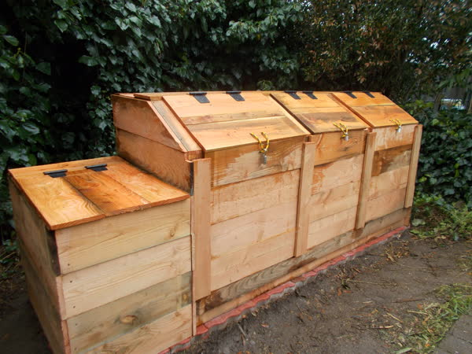
Finished compost container and its container for ground material, on the left.
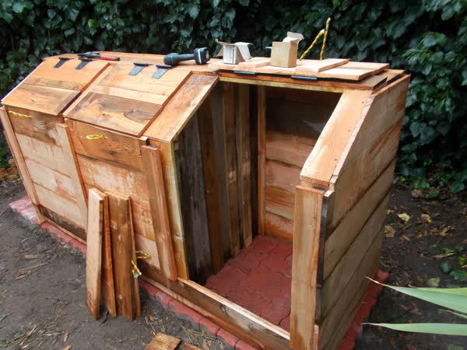
Example of an open container.

Compost durations
It takes nine months in Metropolitan France to compost kitchen waste. It is possible to use it six months in, when it is newly made, but not entirely decomposed. Up until twelve months, it is still fresh enough to contribute to a living soil.
For composting toilets, we recommend waiting two years after having flipped and aired out the compost regularly, and up until 18 months for those who want to work more on their composting toilets.
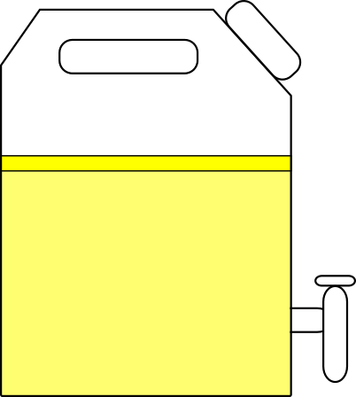
It is easier to manage it using a urine separator. You can reuse the urine right away. If you add oil, it will block the interferences with air and smells. A faucet will help collect the urine.
For the manure, you will have to wait six months to have a humic organic soil enricher. Before that, it is possible to use it after two or three months to stimulate the bacteria in the soil.
For industrial compost, it all depends on what is composted and potential legal measures.

Compost distribution
After 9 to 10 months of maturation, the compost is ready to be distributed! We know a compost is ripe when it has a dark brown color, a lumpy texture and a nice forest-like smell.
For compost distribution, you can:
- chat with users of a community compost;
- chat with your neighbors with a garden;
- put it in a community garden;
- give it to the management of green infrastructures;
- sell it, if you are authorized.
According to situations and countries, there can be limits to its distribution.

Maintenance

Aeration
The more solid the brown waste is, the less important it is to air it out.
You can move it once every month, when the waste is very solid, but every two weeks is better.

Flipping and maturing
After three months, you can flip the pile. The compost will start its maturation process for three new months. This action has to be repeated a second time.
By doing so, you stir the decomposing matter and air it out. By adding air to the compost, you encourage the proliferation of aerobic bacteria which help decomposing the matter.

Bioindicators
After some time, it will become easier to identify the aspect and the presence of such-and-such insects.
These bioindicators give us a lot of insight on what is going on.

Flies, smells
The amounts of brown materials, relative to green materials, depend on what we are using. If there are too many flies, a sticky mass aspect, or even if the smells are too strong, the compost probably lacks brown materials and needs to be mixed.

Compact balls
Then, you need to shuffle, mix and air the compost out.

Mycelia filaments on the surface
The compost is slightly moist. If there are too many mycelia filaments on top of your compost, it might be because it is too dry. You can check if it is the case. You can use a headed watering pot, ideally with rainwater, at ambient temperature. Ideally, the compost is slightly moist.
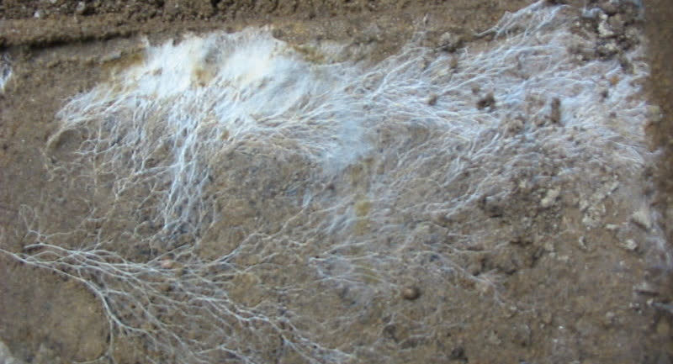
Mycelia filaments (Picture by “Lex vB”, CC BY-SA license).

Tools
Everyone uses the tools they prefer, but it is important to be able to move, manipulate, air out and observe the compost.
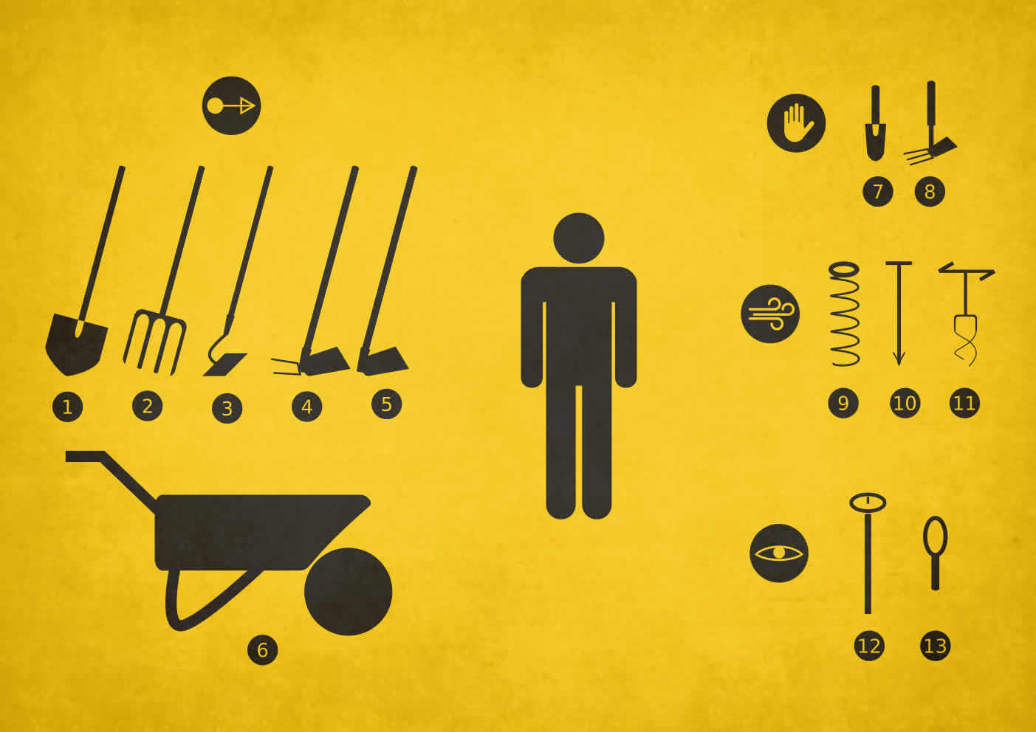
Here are some of the most used tools:

Moving
To move it, you can use a spade (1) or a pitchfork (2), according to the kind of compost. You can also use it to air out the compost, although it will not work as well as tools made specifically for this.
Different kinds of gardening tools, like hoes or weeding hoes (3, 4 and 5) are not mandatory but can help you shuffle the compost to plow it more easily afterwards.
A wheelbarrow (6) can also be useful if you need to move large quantities of compost.

Manipulate
A garden trowel (7) or a weeding hoe (8) can help you retrieve elements in the compost, break up clustered elements or large clumps.

Airing out
There are a few tools made to air out the compost (9, 10 and 11). Some of them are more efficient than others. The simple mixer (10) is usually the tool that works the least.

Observing
To observe bacterial activity in the compost, you can use compost thermometers (12). Temperatures can reach about 70°C. Under the action of bacteria and fungi, the temperature during the decomposition rises up to 70°C.
The dial shows temperature areas. There is:
- low bacterial activity between 20°C and 40°C,
- moderate bacterial activity between 40°C and 55°C,
- high bacterial activity between 55°C and 70°C.

A low bacterial activity may show that the compost lacks air for bacteria, or that they have already done their job and there is nothing else to break down. If it lacks air, you have to air out the compost (by turning it or using a compost ventilation).
A high bacterial activity does break down quicker, but you have to make sure that the heat does not dry up the compost. If this is the case, you can water the compost with room-temperature water.
You can find a compost thermometer in garden centers or buy it online.
Use a magnifying glass (13) to witness life in your compost.
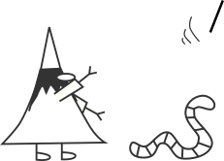
For farmers or manufacturers, there are machines made specifically for larger operations. For example, a hay rake or a tedder.

Communication
It is important to talk about habits on shared spaces.
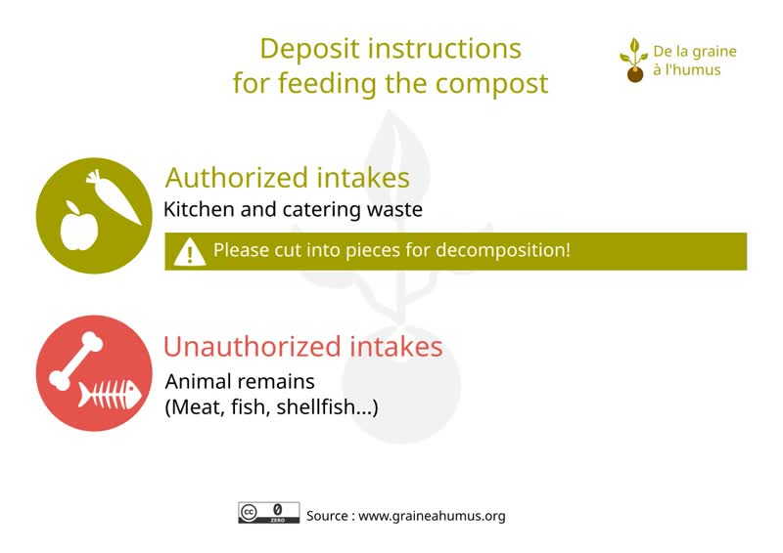
Instruction example No. 1
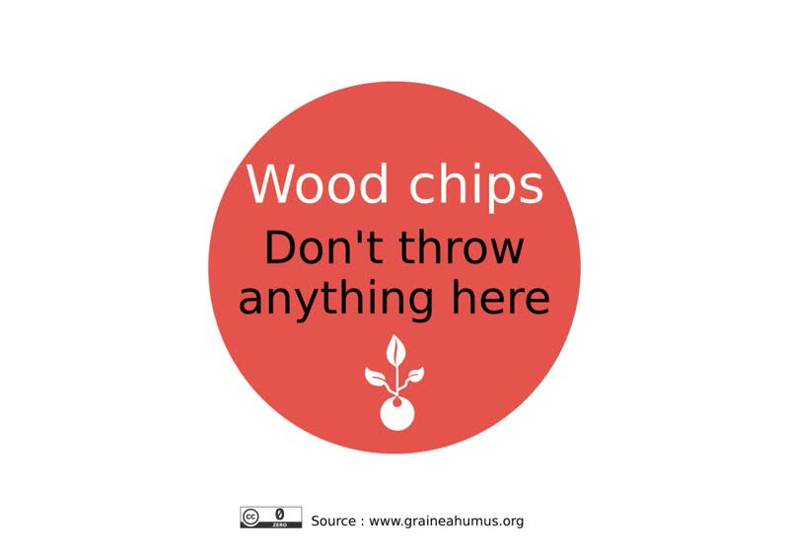
Instruction example No. 2

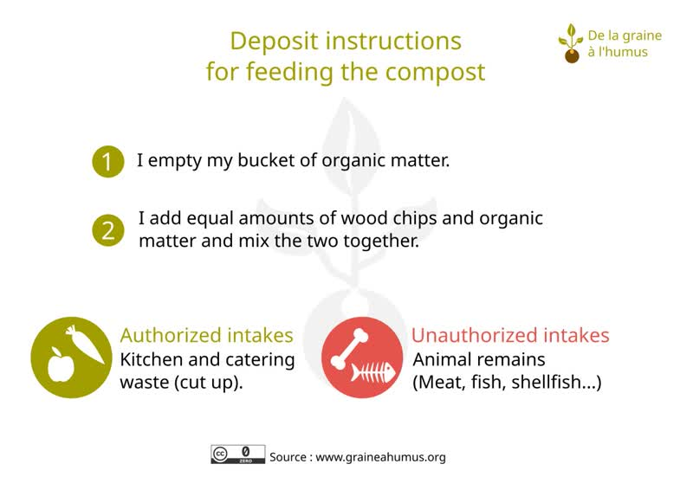
Instruction example No. 3
Although everything can be composted, instructions are specific to those who use the compost.
A small introduction will help to learn a bit about composting before using it.

How to use a compost

Types of use

Potting soil
A potting soil is made up of a mixture of dirt and compost. It is put in a hole just before planting or around two weeks before (usually during the spring, but it can be done during the summer in the vegetable garden). The quantities and types of potting soil to use depend on each plant.

Potting soil from cutting soils
It is a sieved potting soil used to make seedlings and cuttings. The quality of the potting soil (such as the ratio of compost to sandy dirt) depends on the plant. It is usually done by putting the potting soil in pots outside or in greenhouses.

Compost
Compost is more often used on the surface. It may be added to the soil by scratching it or using a hoe.
- Spread the compost at the stem of the flowerbeds and along the borders before incorporating it (around 3 kg of compost per m²).
- Place a 3 to 5 cm layer of compost on hoed soil at the stem of shrubs, fruit trees, rosebushes and perennials.
In the vegetable garden, incorporate the compost to the soil a few weeks before the seedlings. Bury 20 liters of the mixture (¼ of compost and ¾ of dirt) per m² of plantation hole. You can also use:
- 2 liters/m² of compost (garlic, onions, shallots, potatoes…),
- 4 liters/m² of compost (beans, carrots, endives…),
- 5 to 8 liters/m² of compost (tomatoes, bell peppers, lettuce, leeks, strawberry plants, marrows, melons…).
You can find more information on the internet or even in books, such as the excellent Le guide terre vivante - Composts & paillages by PÉPIN Denis.

Bibliography
Links to other resources



Resources

Self-promotion
- https://www.graineahumus Sharing social and environmental projects (free and collaborative resources).
- https://www.opengreendata.com/-francais-?lang=en Database for social and environmental collaborative data.

Books

Le guide terre vivante - Composts & paillages: recycle your biowaste to feed the soil by PÉPIN Denis.

Sources
Information on living things in a compost essentially come from Wikipedia.

Annex
Additional information…


The Earth and the soil
Soil is a primordial resource whose creation process is intrinsically linked to the creation of planet Earth and the development of the living things upon it. Acknowledging it can help to respect this resource.
And Earth created the soil, but it took some time…
Earth is roughly 4.6 billion years old. If Earth was 24 hours old, here is what its phases, called eons, would look like:
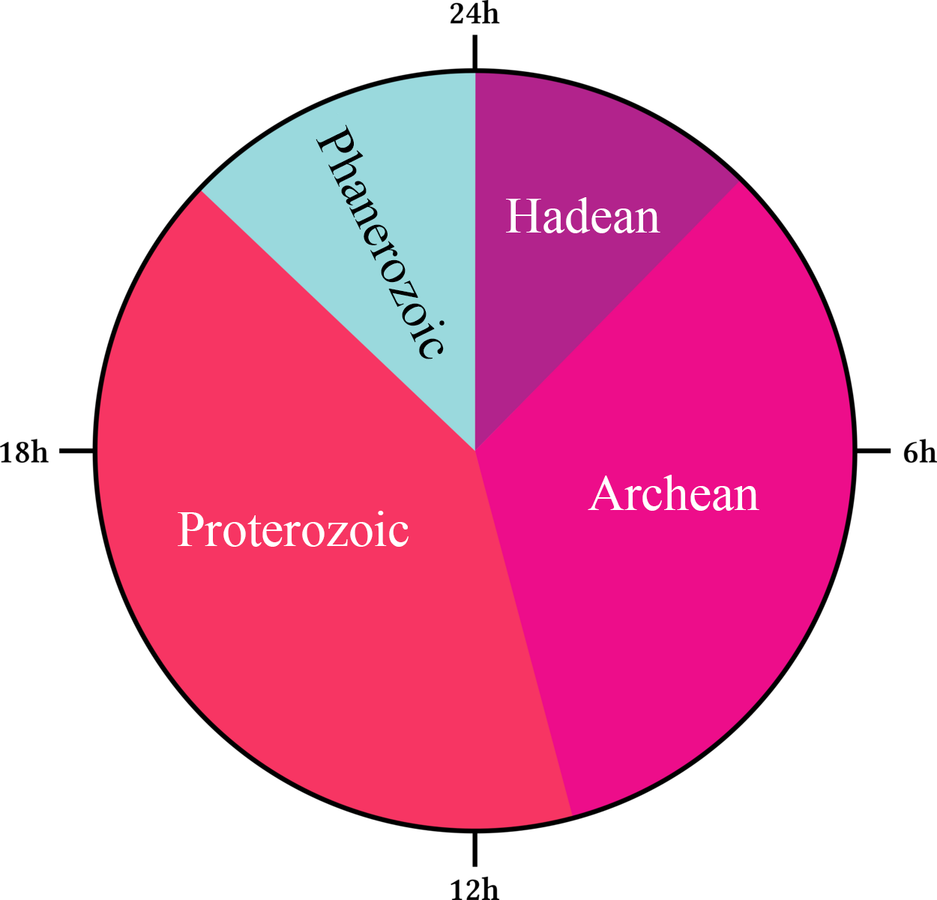
The 4 eons of Earth (illustration by “Geodigital”, CC BY SA license).

Hadean
The Hadean is the first eon, stretching from 4.6 Ga to 4 Ga. At this time, Earth is not the most welcoming place for living things.
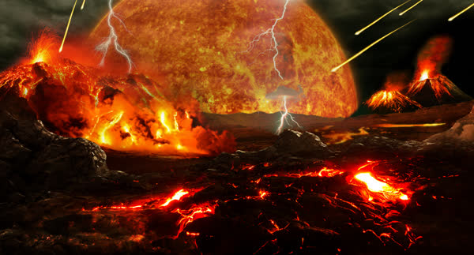
Artist’s impression (Tim Bertelink, CC BY SA license).
Archean
The Archean (4 Ga to 2.5 Ga) is home to the earliest known life forms: bacteria (3.8 Ga).
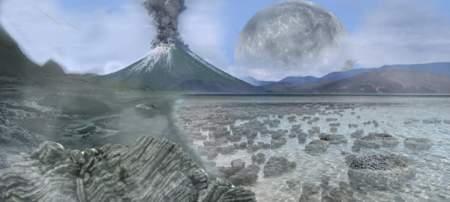
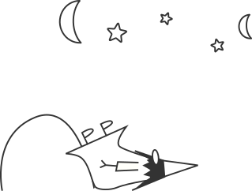
Artist’s impression (Tim Bertelink, CC BY SA license).
Proterozoic
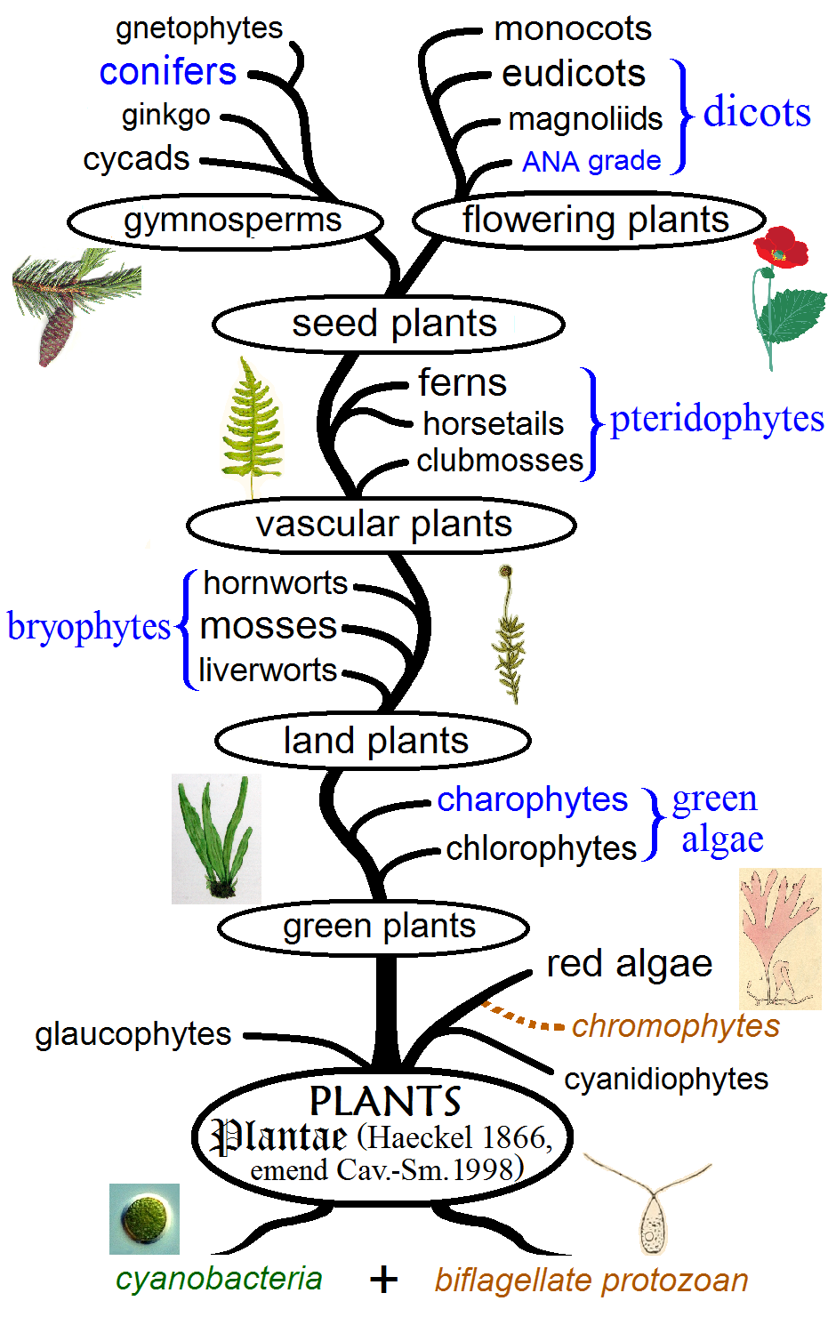
During the Proterozoic (2.5 Ga to 541 Ma), the oxygenated atmosphere appeared.
Some “simple” life forms come together to give life to plants that will then evolve.

Illustration of the evolution of plants (by “Maulucioni”, CC BY SA license).
Phanerozoic
Finally, during the Phanerozoic (541 Ma to the present), animal life has proliferated. That is also when the five major extinction episodes happened.
And what about the soil, then?
The creation and the quality of living organisms in the soil are directly linked to living things. The first traces of paleosols roughly date back to 3.7 Ga.
It takes approximately 100 to 1000 years for the formation of 1 cm of soil.
Pedogenesis is the study of soil formation. It studies diverse phenomenons such as the decomposition of living beings, bedrock disintegration, the transportations of matter, etc.
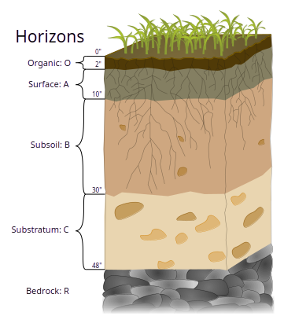
O - The organic surface layer is where dead organic matter lies, such as remnants of living things.
A - The surface soil is where organic matter (on the top) and mineral matter (on the bottom) mix up. The O and A surfaces form the arable soil.
B - Accumulation of mineral matter under the topsoil.
C - Layer of bedrock disintegration.

Illustration of the soil horizon (by “Wilsonbiggs”, CC BY SA license).

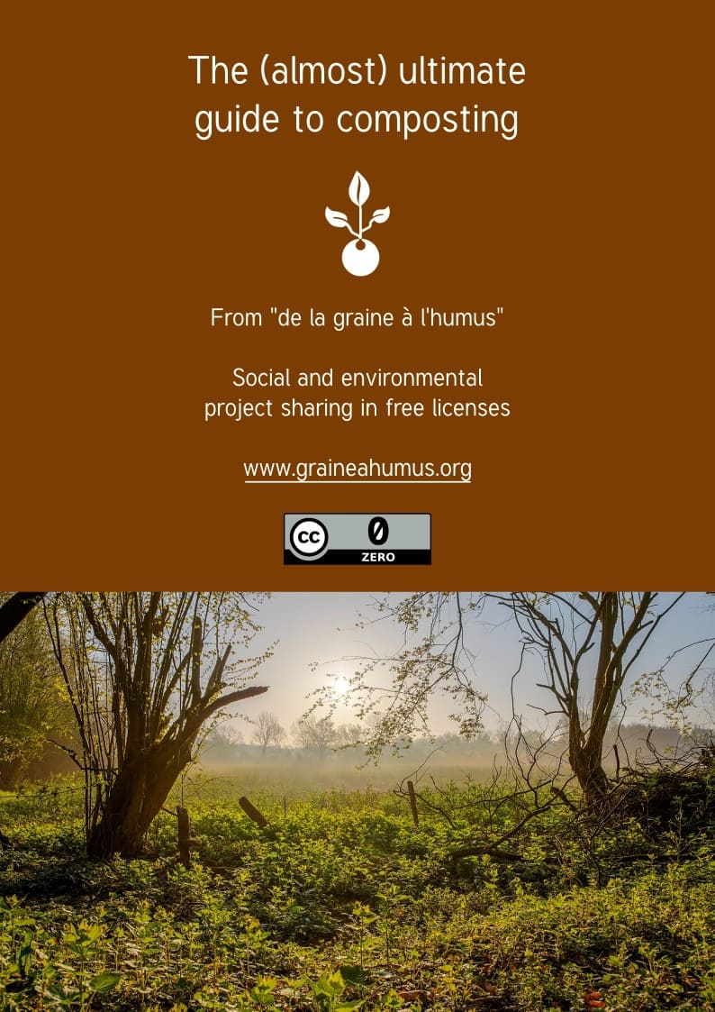

That which "mimics" life.
Source: https://www.inrae.fr/dossiers/peut-encore-sauver-sols/sols-essentiels-vie. In fact, data vary more than that; it allows however values that are easier to remember. For more precise information, you can read https://en.wikipedia.org/wiki/Soil_formation
That emulates living things.
From legislative definitions.
Approaches that take nature as a model.
95.1% for minerals used as fertilizers: in 2017. Source: https://www.notre-environnement.gouv.fr/themes/economie/l-agriculture-ressources/article/les-livraisons-d-engrais-en-france
Glomerales fungi order (mycorrhizal fungi)
Like polyculture, permaculture, rotations, the development of plants and natural habitats, the minimization of soil plowing and tools, agroforestry, the food forest, but also in a less production-driven ambition like renaturation, preservation, protection, rehabilitation, decontamination…

